Tsali Lodge 134

2013 Planbook

I. Lodge Information
Lodge Chief's Introduction
Purpose of the Order
Lodge Mission
Lodge Goals
General Lodge Information
Lodge Key 3
Lodge Officer Bio's Lodge Committees
Lodge Chapters

Lodge Calendar
II. Member Information
Opportunities to Serve
New Members Information
Brotherhood Membership
III. History
Legend of Tsali
OA History
Tsali Lodge Timeline
Past Lodge Chiefs
Vigil Roster
DSA Recipients
Honor of Life Membership
Founder's Award
IV. Rules and Budget
Lodge Rules
Standard Operating Procedures
Lodge Budget
V. Membership Roster
Cataloochee Chapter
Nantahala Chapter
Soqua Chapter Terrora Chapter
Toe River Chapter
Index

•······························································
•······························································ •······························································ •······························································ •······························································ •······························································ •······························································ •······························································ •······························································ •······························································

•······························································
•······························································ •······························································

•······························································
•······························································ •······························································ •······························································ •······························································ •······························································ •······························································ •······························································

•······························································
•······························································ •······························································

•······························································
•······························································ •······························································ •······························································ •······························································

-1-

2
2334679
13 14

18
19 20

21
24 27 31 32 36 36 37

38
41 44

45
46 46 49 51

Welcome to Tsali Lodge

A Few Words from the Tsali Lodge Chief

Brothers,
First off, I would like to thank you for taking the time to look though the contents of this
planbook. In it you will find most of the things you will need to understand Tsali Lodge and the
Order of the Arrow better. Our lodge depends on members like yourself and this planbook is designed to guide you towards a productive and excellent year for Tsali Lodge.
Always remember that "You were selected for membership in the Order because your fellow
Scouts saw your sincerity and acceptance of the high ideals of the Scout Oath and Law," your first
obligation is service to your unit, and that your experience in the Order of the Arrow should
primarily enable you to give back more to your troop. I encourage all members to become involved
within the lodge, and there are several areas to do so as mentioned and explained in this planbook. The success of the Lodge depends greatly on your knowledge of our Lodge goals, its purpose, its organization, and your participation.
.
I look forward to working with you for the future of Tsali Lodge, helping members becoming more
involved, strengthening our bonds of friendship and making our "Brotherhood of Cheerful Service" a fantastic experience for us all this upcoming year.

Always in Brotherhood,
Travis Broadhurst
2013 Lodge Chief

Purpose of the Order
1. To recognize those campers - Scouts and Scouters - who best exemplify the Scout Oath and
Law in their daily lives and by such recognition, cause other campers to conduct themselves in such a manner as to warrant recognition.
2. To develop and maintain camping traditions and spirit.
3. To promote Scout camping, which reaches its greatest effectiveness as a part of the unit's
camping program both year-round and in the summer camp, as directed by the camping committee of the council.
4. To crystallize the Scout habit of helpfulness into a life purpose of leadership in unselfish
service to others.

-2-

Tsali Lodge Mission
The mission of the lodge is to achieve the purpose of the Order of the Arrow as an integral part of
the Boy Scouts of America in Daniel Boone Council through positive youth leadership under the guidance of selected capable adults.

2013 Tsali Lodge Goals

1. To improve chapter involvement in Lodge events and promote chapter identity

2. To hold elections for 100% of the troops in the council that want elections

3. Maintain brotherhood conversion of 40% and membership retention to keep the

highest Journey to Excellence distinction.

4. Be competitive again for "Lodge of the Year" at Dixie fellowship

5. Increase attendance at lodge functions to 20%

6. To remake the website and keep it updated

7. Keep the planbook and Where To Go Camping Guide up-to-date and

distributed to all in need

8. To compete in all events at Dixie

10. To increase committee involvement

11. To do more service to the community and to

the council

-3-

General Lodge Information

Council Address: OA Sash:

Daniel Boone Council, BSA 333 West Haywood St.
Asheville, NC 28801
(828) 254-6189

Fax # (828) 252-4818
Camp Daniel Boone -- (828) 648-0435
www.danielboonecouncil.org

Lodge Totem:
The lodge totem is that of the "bow". Within the
bow are two letters of the Cherokee alphabet,
which spells out Stale's name (Pronounced "Cha-
hi")

Tsali Lodge Totem

Lodge Newsletter:
"The Bow" is the Lodge's newsletter that is
published four times per year. Inside "The Bow"
you will find information and registration forms on upcoming events, articles of ideas, opinions,
and reviews of past events. Also included are the
lodge officer phone numbers and emails for contact purposes.

Uniform:
Official uniforms for lodge events include a scout
uniform and OA sash. Official uniforms must be
worn at dinner during lodge functions, at the winter banquet, Lodge Executive Committee
meetings, and all the other lodge functions.
During workdays, service projects, and activities,
uniforms are not always required, depending on the type and location of the activity. Remember, the OA is the Honor Society of the Boy Scouts. We should set the example.
The OA Handbook describes the correct
method of wearing the OA Sash. It states that the sash is to be worn only at official
OA functions and with the Official uniform, Elangomats in the Ordeal
excepted, and any other occasion
approved by the Scout Executive. At all other non-official OA functions, the flap,
pocket ribbon and pin are the official symbols of membership in the OA.

Lodge Website:
The lodge website is www.tsalilodge.org.
On this website you can find everything from registration forms and calendars to the legend of Tsali and the recipients of
the Founder's award, Vigil Honor and the Distinguished Service Award. There is a
lodge forum for posting questions and
getting answers, and there is information
about the lodge government and upcoming events. (This website
complies with the National criteria and
outline for websites.) For Lodge members with Facebook accounts
(www.facebook.com) be sure to join the
Tsali Lodge Facebook group to receive
up-to-date information on upcoming
events. To create a Facebook account, go to www.FaceBook.com - all you need is a valid email address.

Lodge Dues:

Annual dues for Tsali Lodge Arrowstmen
are $8 and are due on December 31 .
Forms for dues payments are available in
the Daniel Boone Council's newsletter, "The Long Rifle", "The Bow", or online
at the lodge's website at www.tsalilodge.org.

-4-

Lodge Patches:

In the past, Tsali Lodge issued three different lodge flaps, one for each honor in the order.
But a new national rule says that there can be
no difference in the flaps for the different
honors. Our new patch features a Cherokee
wearing authentic regalia similar to that of the new Indian Affairs programs in the lodge.
The Cherokee is holding a gourd rattle (Which is used in several of our group dances), and an
eagle-feather fan (which is used in our group
Eagle Dance). This issue came out in 2011
with a ghosted blue fleur-de-lis

On this retired issue is the Lodge's totem (the
long bow) and five Cherokee Indians that
represent Tsali, Tsali's Brother, the Cherokee
chief Utsala, and Tsali's two sons. Though
these are not the current issue it was in use for
several years and many lodge members will still have them on their scout uniforms.

This is the flap commemorating Tsali lodges

Current Tsali Lodge Flap

Retired Tsali Lodge Flap

service to one of the National Events. Tsali nd
was chosen to be the Service lodge for the 2
ever Indian Summer. This issue has a felt back
ground and a flowery design that the
Cherokee used. The Lodge Totem is in the Center.

The lodge will occasionally issue event
patches for lodge events like fellowships and
the Winter Banquet. The patch shown at right
was issued to all members who attended the 2011 fall fellowship.

NOAC

2013 Fall Fellowship patch

-5-

** Yearly updates for this section will be sent out in a planbook supplement

2013 Lodge Government, Advisers, and Goals

The "Key Three"
Lodge Chief: Travis Broadhurst
The Lodge Chief: presides at all Lodge Executive Board
Meetings, supervises all Lodge Vice-Chiefs and committee
chairmen and sees that they carry out their duties, sees that all Lodge functions are properly planned for and conducted, and
consults regularly with the Lodge Lay Adviser and Staff Advisers.

Phone: cell- 828-989-0224
Email: tsalilodgechief@gmail.com
Address: 117 Hillcrest Drive, Weaverville, NC 28787
Travis Broadhurst
Lodge Adviser: Dan Little
The Lodge Adviser: serves as a liaison between the
youth and adult members of the Lodge. He is the closest Adviser
to the Chief and Executive Committee. He encourages
involvement and facilitates discussion of different issues concerning the lodge.

Phone: (home) (828) 298-1452
(cell)- 828-231-8029
Email: danieldlittle@bellsouth.net
Address: 20 Fuller Lane, Ashville, NC 28805
Dan Little
Staff Adviser: Anand Suthar
The Staff Adviser: is a professional Scout with the
council. He is an essential link in coordinating schedules,
planning programs, and managing finances. He also serves as a contact for the lodge in the council.

Phone: (828) 252-4818 / cell- 706-255-1254
Email: asuthar@bsamail.org
Address: Daniel Boone Council
Boy Scouts of America
333 West Haywood Street
Anand Suthar Asheville, NC 28801

6

Officer Bio's
Lodge Chief, Travis Broadhurst:
My name is Travis Broadhurst, and I am your 2012-2013 Tsali lodge chief! I’m so excited to be lodge chief for this year and I really think I can help our lodge grow and get a 4 th consecutive lodge of the year at Dixie (which everyone should go to). I am a junior in High School, am 17 years old, and have 2 brothers. I live in WeaverVegas, North Carolina, and I attend North Buncombe High School. I enjoy helping others through cheerful service, skiing, football, basketball, Boy Scouts, camping, any outdoor recreational activity, playing the electric bass, waterskiing, and traveling. I love to go and see new places around the world. I have been a Boy Scout since 2006, and was a Cub Scout before that. I am an Eagle Scout, and have been in the OA since 2009. I attained my Brotherhood in 2010. Since then, my leadership has gradually grown and I have become more involved in the lodge. Last year, I was the Brotherhood Conversions Committee Chairman and our percentage of arrowmen achieving brotherhood climbed to 35%. We had enough Brotherhood members to be a Quality Lodge. I was the Where to go Camping Committee Chairman, and the Where to go Camping Booklet helped Tsali get lodge of the year. I was also Ceremonies Chairman for the latter half of the year. Serving in all of these leadership roles really helped me appreciate all the planning that goes into our events by the lodge leadership and adult assistance. This is why I wanted to be a part of it so that I could make this possible for all present and future arrowmen.
As lodge chief, I will work to continue our success and accomplishment through Dixie competitions and the cheerful service that we are known for. I would be ecstatic if we could get a Nantahala chapter involved through outreach to that district, and if we could increase participation from the other chapters to make the Quest for the Golden Feather quite competitive.We have a great leadership team of officers this year, all of whom you will get to meet later on in the Bow. If anyone is interested in joining and/or being the chairman of a committee in the lodge, let me know or talk to the respective vice chief for that committee. It is a great way to get more involved in the lodge and help us flourish so that we can better serve Daniel Boone Council and the rest of WNC.Let’s make this another great year for Tsali Lodge!!!!

Vice-Chief Administration, Chambers Loomis:
My name is Chambers Loomis, and I am your 2012-13 Vice-Chief of Administration. I have had the pleasuring of serving Tsali Lodge in the capacity of Vice-Chief of Administration, Vice-Chief of Program, Soqua Chapter Chief, and Memorabilia and Distribution Committee Chairman. My efforts over the next year will be concentrated on membership retention, dues, unit elections, brotherhood conversion, and communications. The planbook is essential to effective communication in our lodge, so I will ensure that they are made available at each event. Additionally, I will work to fully utilize email, the lodge website, and the lodge Facebook page as effective tools for communication. I plan to appoint a reliable unit elections team leader in each chapter in an effort to increase new membership. Lastly, I will work closely with our Vice-Chief of Program to make our events attractive to new ordeal members, thereby increasing retention. Serving on a committee is an excellent way to become involved in the lodge, so feel free to email or call me about joining one. Let's all look forward to another successful year for Tsali Lodge!
7

Vice-Chief Program, Kameron Vaughn:
My name is Kameron Vaughn and I am the 2013Vice Chief of Program. Over the next year, I will be working closely with the other Tsali Chiefs to plan and prepare for our upcoming trip to Dixie 2013. Along with these big events I am also in charge of running programs going on at Camp Daniel Boone during ordeals, fellowships, and other smaller lodge events. Communication within the Lodge has always been the biggest challenge in retaining membership and keeping people excited and informed about all upcoming events. I hope to better this communication by heavily integrating new technology such as the lodge website (www.tsalilodge.org), Facebook page (https://www.facebook.com/groups/Tsalilodge134), and lodge email (tsalilodgechief@gmail.com). The continued membership of you and your friends is vital in keeping our Lodge an award-winning program every year. Feel free to contact me if you have any suggestions regarding program, have an interest in joining a committee, have a work idea for Ordeal weekends, or have any other Lodge program concerns. I look forward to a great year with Tsali Lodge!

Vice-Chief Indian Affairs, Dakota Johnson:

Lodge Secretary, Kevin Elliott:
My name is Kevin Elliott and I am your 2012-2013 Lodge Secretary. I am a senior at Brevard High School and an Eagle Scout of Troop 701 in Brevard. Last year I served the lodge as the Dixie/NOAC Committee Chairman. My goal as secretary is to improve the lodge communications and the Bow. I would like to have the Bow sent out monthly or bi-monthly so that every Arrowman is aware of all of the past and upcoming events. By improving the communication and the Bow, I hope to have larger turnouts at lodge events. I am thankful for being elected as Lodge Secretary. I am looking forward to another great year!

8

Lodge Vice-Chief of Administration: Chambers Loomis
Acts as the Lodge Chief in his absence and is responsible for all administrative committees

Chambers Loomis
Phone: home- (828) 274-8552
cell- (828) 279-4734
Email: chambers.loomis@gmail.com
Address: 5 Cedarchine Rd,
Asheville, NC 28803
Adviser: Tony Johnson
Phone: 828-231-8030
Email: johnsoto@nationwide.com
Address: 735 Macedonia Rd, Asheville, NC 28804

Vice-Chief of Administration is generally responsible for lodge membership, dues, elections, and
communications. He over sees the Finances of the lodge he makes sure that this planbook is updated
and looking better than ever. He makes sure that the lodge gets the brotherhood conversion rating that they need for the new Journey to Excellence, 40% this year. He makes sure the website gets updated and one of the most important things he does is unit elections and camping promotions.

Planbook Committee: Brotherhood Conversion Committee:
Helps with the writing and publishing of the Lodge Planbook; a Encourages Ordeal members to attain their Brotherhood
book that give out the basic information about the Lodge. membership. Conducts "Brotherhood Enrichment" classes
at Ordeals and Lodge fellowships.

Chairman
Cameron Barnett
c) 828-989-6652
cameron889@hotmail.com

Adviser
Hank Birdsong
w) 828-885-2153 h) 828-883-9316
hbirdsong@gmail.com

Chairman
Travis Broadhurst
c) 828-645-2819
geo.travis@yahoo.com

Adviser
Colleen Shipley
h) 828-898-9469 c) 828-260-0399
shipleybsa@hotmail.com

Where to go Camping Book Committee: Lodge Website Committee:
Gathers information, writes, and publishes the Lodge's Book on Maintains the lodge website and keeps it up-to-date with
camping in our area. the most recent news and information on the lodge.

Chairman
Danny Magley
c) 828-545-7796

Adviser
Hank Birdsong
h) 828-885-2153
c) 828-883-9316
hbirdsong@gmail.com

Chairman
Johnathan Neiman
c) 828-273-3894

Adviser
James Hylemon
828-275-3075
jameshylemon2010@yahoo.com
Elections / Camping Promotions Committee:
Promotes camping to the troops of the council and encourages
Scout Summer Camp and other outdoor programs through
Chapter Chiefs and OA Troop Representatives. Oversees troop OA elections, which are done during the spring and makes sure all troops have elections.
Membership and Finance Committee:
Maintains the lodge membership data base and provides
mailing labels for The Bow, determines which brothers
are eligible for Brotherhood and Vigil honors. Develops annual lodge budget.

Chairman
Kiffen Loomis
c) 828-333-8961
kloomis@christschool.net
Adviser
Greg Bias
828-337-9935
fbias@charter.net
Chairman
Cameron Barnett
828-989-6652
cameron889@hotmail.com

Adviser
Anand Suthar
706-255-1254
asuthar@bsamail.org

9

Vice-Chief of Indian Affairs: Dakota Johnson
The Vice Chief of Indian Affairs: is responsible for all Indian Affairs committees.
Dakota Johnson Adviser: Bill Dyar
Phone: (828) 808-0138 Phone: h) 828-524-8129 c) 828-421-3567
Email: johnsd31@aol.com Email: billdyar@frontier.com
Address: 735 Macedonia Rd, Asheville, NC 28804 Address: 104 Camp Rd, Franklin, NC 28734

Vice Chief of Indian affairs is generally responsible for and over sees every Indian Affairs aspect of our lodge. He is responsible for making sure the Ceremony teams are ready for each ceremony. He typically competes on the Group Dance Team, as well as the Team Sing, at Dixie and at NOAC. He
makes sure that our lodge has individual dancers ready to attend any Pow-Wow in the area including Dixie and NOAC.

Ceremonies Team Committee: Individual Dance Committee:
Organizes and oversees the Ceremonies in which the Organizes and oversees the development of individual lodge performs. dancers for competition at the Dixie Fellowship and NOAC.

Chairman
Adam Kull
C) (828)-458-7235
cudfanadam@frontier.com

Adviser
John Lampley
h) 828-697-6818
jwlampley@juno.com

Chairman
Kevin Elliott
c) 828-450-9766
kevelliott12@gmail.com

Adviser
Bill Dyar
c) 828-524-8129
h) 828-421-3567 billdyar@frontier.com

Group Dance Team Committee: Drum / Singing Team Committee:
Organizes and oversees the development of a group Organizes and oversees the development of a group
dance team for competitions and demonstrations at lodge singing team for lodge fellowship performances and events. competition at Dixie Fellowship and NOAC.

Chairman
Gabe Neckolaishen
gneckol@gmail.com

Fire Warriors Committee:
Sets up all ceremony circles, and builds the fire, and cleans up before and after each ceremoney
Advisor
Bill Dyar
h) 828-524-8129
c) 828-421-3567
billdyar@frontier.com
Chairman
Brenden Elliott
C) (828)-862-5655
Bbelliott1331@yahoo.com

Fire Warriors Comittee
Adviser
Hank Birdsong
w) 828-885-2153
h) 828-883-9316
hbirdsong@gmail.com
Chairman Advisor
Brendon Elliott John Lampley
h) 828-450-9593 c) 828-697-6818
bbelliott1331@gmail.com jwlampley@juno.com

10

Vice-Chief of Program: Kameron Vaughn
The Vice-Chief of Program: is responsible for all Programmatic Committees.
Kameron Vaughn Adviser: Mike Mann Adviser: Jay Madill
Phone: 828-550-0741 Phone: h) 667-4386
Email: kameronvaughnvcop@gmail.com Email: elkmann@bellsouth.net
Address: 19 shakleford drive Address: 25 Cole-Mann Dr, Email: mdills6@hotmail.com
Asheville, 28806 NC Candler, NC 28715 Address: Camp Daniel Boone

The Vice Chief of Program is one of the most important roles in the lodge. He over sees and is
responsible for one of the most important committees, the food, as well as several others. He makes sure that the Elangomats are ready prior to the ordeals. He over sees the committee that is in charge
of the service projects as well as the one in charge of the activities. He is also the one to ask about attending and competing at Dixie or NOAC.

Section Conclave / NOAC Committee:
Organizes the lodge's program for Dixie; Theme,
cheers, spirit items, etc. Organizes Quest team and
training. Follows up on Dixie Competition Guidelines.

Kitchen/Banquet Committee:
Plans and cooks the meals at the Lodge functions
and plans the annual Winter Banquet.

Chairman
Kevin Elliott
Phone- 828-862-5655
Email- sbelliott@citcom.net
Adviser
Randal Hylemon
c- 828-275-1972
rhylemon@charter.net
Chairman
Austin Hawkins
Phone- 828-733-0321
Email- N/A
Adviser
Garrick "Doogan" Smith
828-733-2121 (w)
828-387-0636 (c) 828-898-5356 (h)
mgsmithbe@skybest.com

Service Committee:
Plans the cheerful service projects which the lodge
performs during the year and at Lodge functions. Plans annual "Day of Service".
Elangomat Committee:
Organizes and oversees the Lodge's Elangomats and plans
programs for the Elangomats to perform with their Ordeal candidates.

Chairman
Cameron Barnett
828-989-6652
cameron889@hotmail.com
Adviser
Jay Madill
Mdills6@hotmail.com
Chairman
Gabe Neckolaishen
gneckol@gmail.com
Advisers
Mary-Lou Farmer
h) 828-654-0982
eglmakr@netzero.com

Activities Committee: Lodge Memorabilia and Distribution Comm:
Plans the Physical Activities and events that occur Designs lodge memorabilia and merchandise for
during the Ordeals and Fellowships. events. Staffs the lodge trading post.

Chairman
Kameron Vaughn
c) 828-550-0741
kameronvaughnvcop@gmail.com
Adviser
Rick Hulme
c) 828-252-4896
rickhulme@msn.com
Chairman
Chambers Loomis
h) 828-274-8552
c) 828-279-4734
chambers.loomis@gmail.com
Advisers
Mike Mann
h) 828-667-4386
elkmann@bellsouth.net
Weldon Clinard
828-648-7545

thetea_man@hotmail.com

11

Lodge Secretary: Kevin Elliott

Phone: 828-450-9766
Email:
kevelliott@gmail.com

Adviser: Harry Frick Phone: (828) 667-5679
Email: hcfrick@aol.com Address: 32 Country Ln,
Candler, NC 28715

Issue #1:

February 15th Bow Articles Due
• Planbook supplement
• Winter Banquet Recap
February 21st - Bow Mailed

Issue #2:

April 18th - Bow Articles Due
• Dixie wrap-up
• Spring events Wrap-up
April 28th - Bow Mailed

Issue #3:

st
June 15 - Bow Articles Due
• Summer ordeal info
• NLS Info
June 21st - Bow Mailed

The Lodge Secretary: is responsible for taking minutes at all Lodge
Executive Committee Meetings, copying those notes and distributing them
at the next Executive Board Meeting, and completing official Lodge
correspondence. Also gathers and types articles for The Bow newsletter
and distributes the newsletter to the arrowmen of the lodge. He is also the
one that submits the article for the section newsletter "The 5 feathers"

BOW SCHEDULE

Issue #4:

Aug. 15th - Bow Articles Due
• Fall Fellowship info
• Ordeal pictures
Aug. 29th - Bow Mailed

Issue #5:

October 15th - Bow Articles Due
• Fall Fellowship wrap-up
• Fall Fellowship pictures
October 21st - Bow Mailed

Issue #6:

December 10th - Bow Articles Due
• Dues form
• NLS Information • LLD Information
• Dixie Fellowship Information
December 20th - Bow Mailed

12

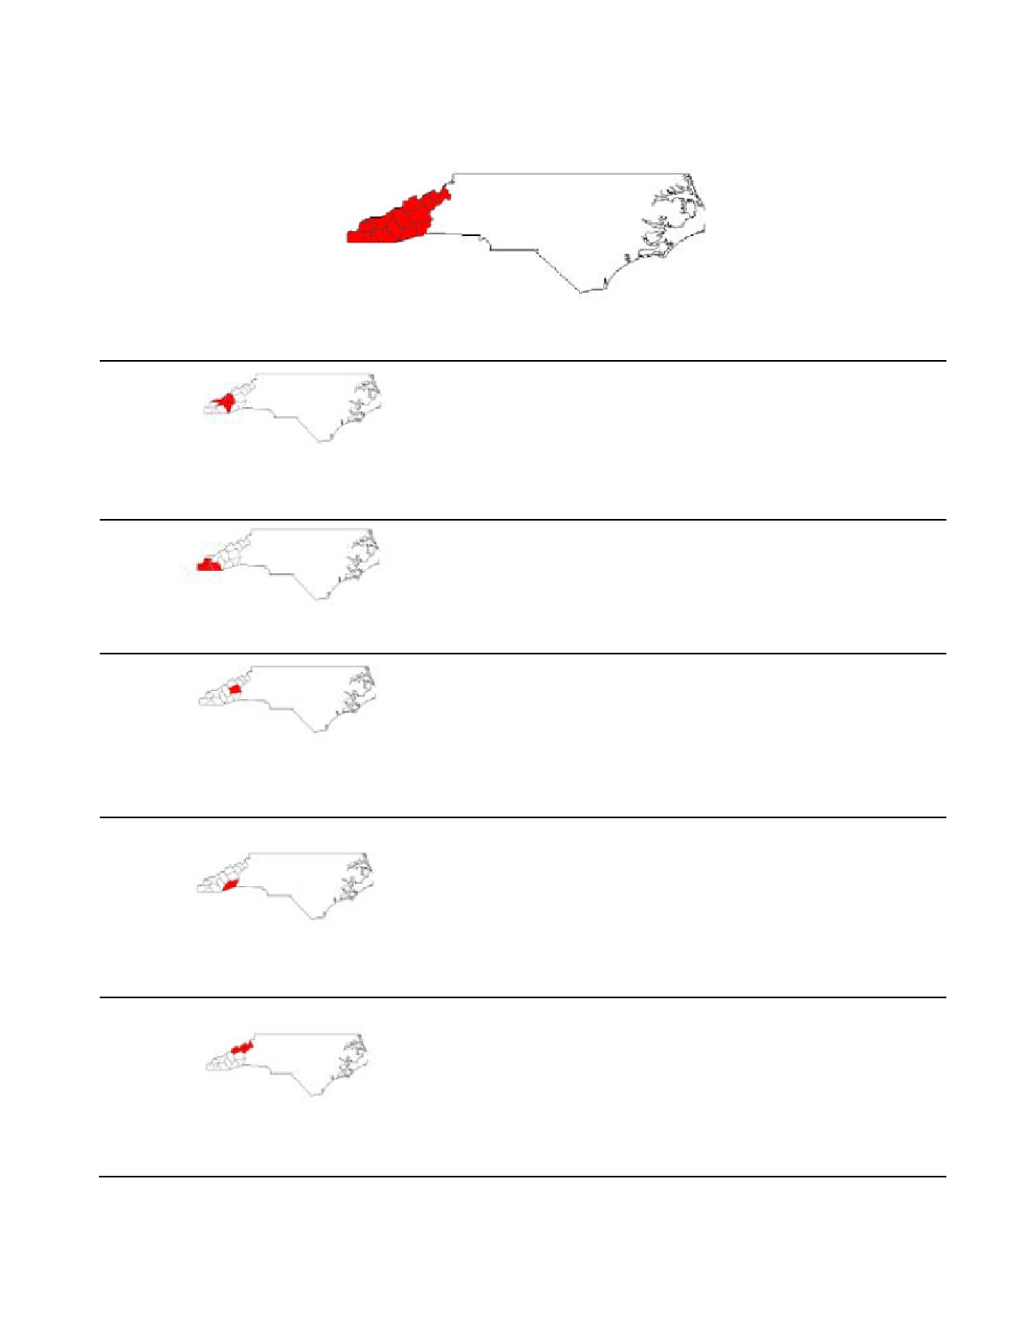
The Chapters of Tsali Lodge

Tsali Lodge covers all of Western North Carolina and is divided up into five chapters: Cataloochee, Nantahala, Soqua, Terrora, and Toe River.
Chapter Chief: Taylor Harnandez
Phone: 828-550-5072
Email: eaglescout0309@gmail.com

Cataloochee Chapter- Includes Macon, Jackson, Swain and Haywood Counties
and Cherokee Reservation

Soqua Chapter- Includes Buncombe
County

Terrora Chapter- Includes Henderson
and Transylvania Counties

Toe River Chapter- Includes Avery,
Madison, Mitchell, and Yancey Counties
Chapter Adviser: Jay Madill
Phone: 828-293-9116
Email: mdills6@verizon.net

Chapter Chief: Kiffen Loomis
Phone: 828-333-8961
Email: kloomis@christschool.net

Chapter Adviser: Randal Hylemon
Phone: (828) 275-1972
Email: rhylemon@charter.net

Chapter Chief: Steven Grayson
Phone: 828-243-1149
Email:19hammerhead97@bellsouth.net

Chapter Adviser: John W. Lampley
Phone: 828-697-6818
Email: jwlampley@juno.com

Chapter Chief: John Clark

Chapter Adviser: Richard Crouse
Phone: (H) 828-766-1122 (C) 828-208-0951
Email: bycrouse@yahoo.com

13

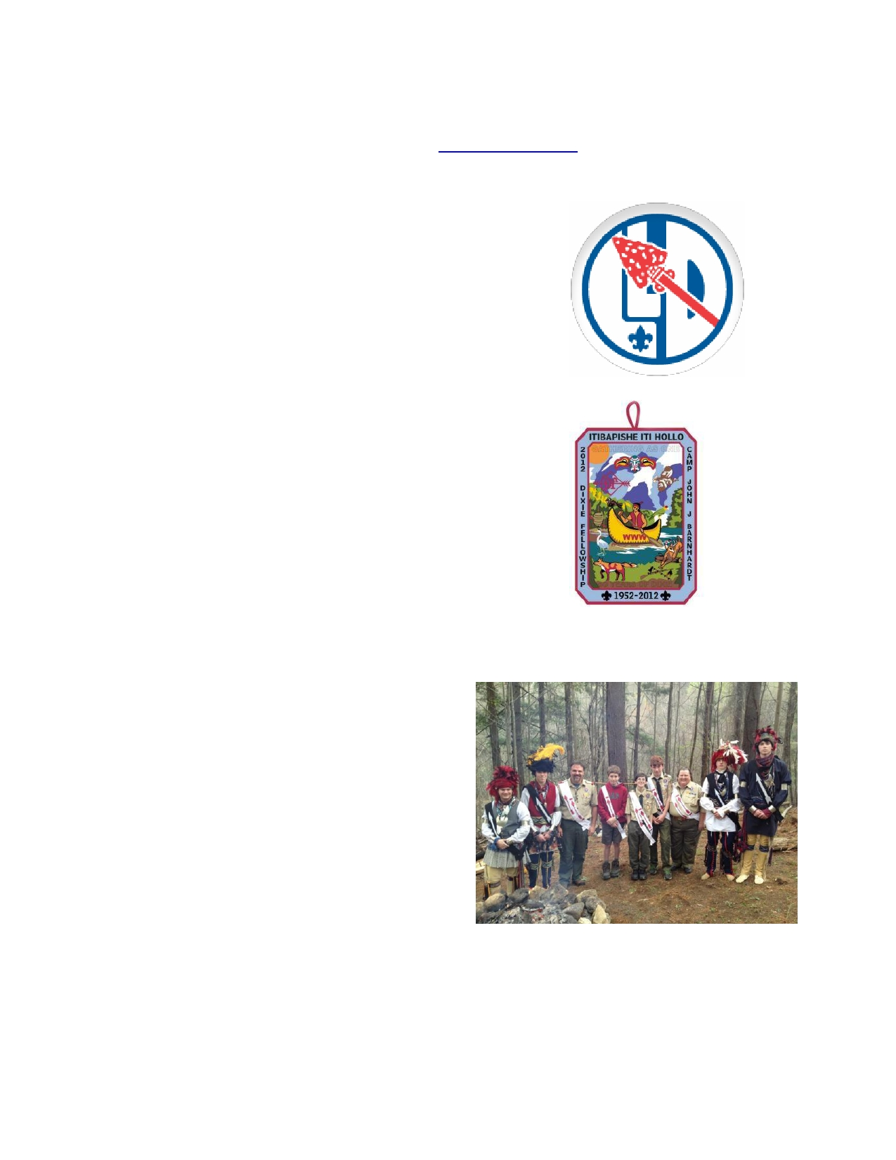
Tsali Lodge #134
2013 Calendar
See following pages for event details & visit www.tsalilodge.org for last minute information

January
4-5- Lodge Leadership Development (Camp
Daniel Boone)

February

March -
15-17- Spring Fellowship (Camp Daniel
Boone)

April
12-14- Spring Ordeal (Camp Daniel Boone)
19-21- Dixie Fellowship (Ho Nan Wah)

June
1- Log Rollin' (Camp Daniel Boone, setting up for summer camp)

July
July 30 - Aug 4 - National Order of
the Arrow Conference

August
24-26- Summer Ordeal (Camp Daniel
Boone)

October
5-7- Fall Fellowship (Camp Daniel
Boone)

14

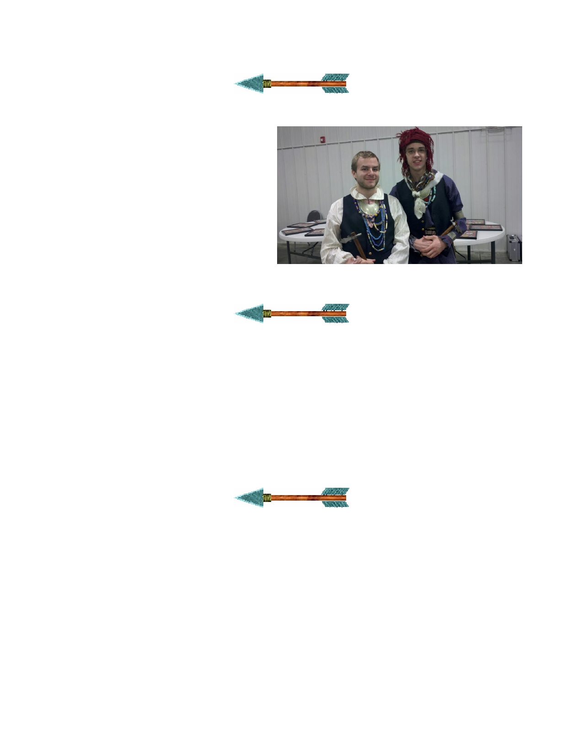
Tsali Lodge Winter Banquet
Date: February 4, 2012
Cost: $20.00
Location: Camp Daniel Boone
The Lodge's annual Winter Banquet will be
held in Ledbetter Lodge at Camp Daniel
Boone. After enjoying a wholesome meal, the Lodge will induct its new officers and recognize outgoing officers. We will also
present the Founders' Award and listen to a guest speaker.

Benjamin and Zach recipients of a special IA Award

Spring Fellowship
Dates: March 30-Apr 1, 2012 (Registration begins at 7:00pm)
Cost: $20.00 (no additional fee if seeking Brotherhood honor or for the banquet)
Location: Camp Daniel Boone

The Spring Fellowship is the Lodge's weekend to prepare for the upcoming Dixie Fellowship.
Dancers and ceremony principals will practice for the Indian affairs events while the other
Arrowmen practice on quest events such as tent pitching, totem pole carving, fire starting, etc. We
will also learn songs and yells; we will also go over the spirit items, etc. Brotherhood
membership will be available this weekend as well. The cost is $15 for brothers attending. These costs include all meals and a new sash for new Brotherhood members.

Spring Ordeal
Dates: April 13 - 15, 2012 (Registration begins at 7:00pm)
Cost: $20.00 (no additional fee if seeking Brotherhood honor); Ordeal Candidates - $40
Location: Camp Daniel Boone

This will be the first of the two Ordeal weekends scheduled for the year. Ordeal candidates who
were elected during the twelve months prior to the Ordeal weekend will attend and go through their Ordeal. For those Ordeal members ready to advance to the next level, Brotherhood will be offered
at this weekend. Fees for the weekend include all meals, Brotherhood sash for new Brotherhood members and an OA Handbook, Ordeal sash and flap for new Ordeal members.

Every member of the Lodge is invited to join in this time of service and fellowship. We members
must be present and acting in accordance with our values in order to lead by example. Please give of your time to help our new brothers on their long journey; help us honor them by working along side them.

15

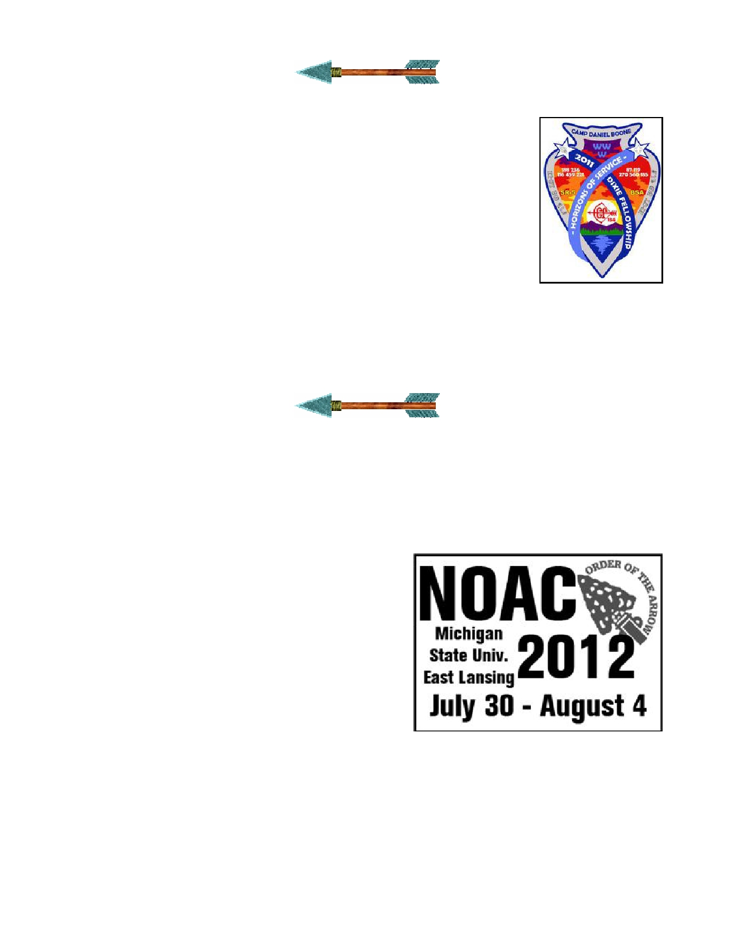
SR-5 Conclave - "Dixie Fellowship"

Dates: April 27-29, 2012
Cost: $60.00
Host Lodge: Itibapishe Iti Hollo
The 60th annual SR-5 conclave, known nationally as the Dixie Fellowship,
will take place Camp John J. Barnhardt off of Hwy. 740, half way between
New London and Badin in Stanly County, North Carolina. At the Dixie
Fellowship, all 11 Lodges in Section SR-5 (which cover parts of NC, SC, &
GA) will come together for a whole weekend of fun and fellowship. From seeing which Lodge can be the loudest and most spirited, to which has the
best ceremony team, there is never a dull moment. In years between
National OA Conferences, the Dixie Fellowship is the highlight of the OA's calendar year.
Check the lodge website, www.tsalilodge.org for more details about the
event, including transportation. The official Dixie fellowship website- www.sr5.org will have additional information about this exciting event.

2012 NOAC
Dates: July 30, 2012 - August 4, 2012
Cost: Youth: $450.00 - Adult: $800.00
Location: Michigan State University (a bus is provided)

Last Year's Patch (Hosted by Tsali)

This event promises to be one of the most fun and exciting times for Tsali Lodge. Every two years,
Arrowmen from across the country gather on the campus of a major university for the National Order of the Arrow Conference (NOAC).
The National Order of the Arrow Conference is
Scouting's second-largest national program event. The
reason for its growing popularity can be attributed to
the fact that it is planned and carried out by Arrowmen
themselves. Youth involvement ensures that the
conference program will be exciting, relevant, and non- stop fun.
NOAC has many different aspects and it is impossible
to participate in every event in one year. Each year
events are added and changed so you could go to NOAC every time and do new things each time.
The main activities at NOAC include training, ceremonies evaluation, American Indian events,
shows, competitions, and Founder's Day. NOAC has something for every one of all backgrounds and all ages. It is definitely one of Scouting's most unique and entertaining events.

16

Summer Ordeal
Dates: August 24, 2012 (Registration begins at 7:00pm) - August 26, 2012 (10:00am)
Cost: $20.00 (no additional fee if seeking Brotherhood honor); Ordeal Candidates - $40
Location: Camp Daniel Boone
This will be the second of the two Ordeal weekends scheduled for the year. Ordeal candidates who
were elected during the twelve months prior to the Ordeal weekend will attend and go through their Ordeal. For those Ordeal members ready to advance to the next level, Brotherhood will be offered
at this weekend. Fees for the weekend include all meals, Brotherhood sash for new Brotherhood members and an OA Handbook, Ordeal sash and flap for new Ordeal members.
Every member of the Lodge is invited to join in this time of service and fellowship. We members must
be present and acting in accordance with our values in order to lead by example. Please give of your
time to help our new brothers on their long journey; help us honor them by working along side them.
Partial Summer Ordeal Checklist:

• Scout uniform, including OA sash
• Flashlight
• Tent (Optional)
• Sleeping Bag • Medical Form
• Ordeal Candidates bring gloves,
groundsheet, work clothes,
raingear
• Cheerful Spirit

Fall Fellowship
Dates: October 7, 2012 (Registration begins at 7:00pm) - October 9, 2011 (10:00am)
Cost: $20.00 (no additional fee if seeking Brotherhood honor)
Location: Camp Daniel Boone
Fall Fellowship is a "don't miss" weekend! Fall Fellowship is all
about fun, fellowship, and training. On Saturday morning you can pick
from many training opportunities- everything from learning how to make
Indian regalia to how to conduct a troop election. You might want to
learn a part in a ceremony or learn what you need to do to become a Brotherhood member, the next step in the OA after induction. In the afternoon we have the "Quest for the Golden Feather", a competition
between chapters of the lodge (the OA version of Districts). Competition
events might include the tomahawk throw, a group tug-of-war, a canoe race, a relay race, egg toss,
or many other fun events! That evening we will have a campfire and watch our Cherokee Dance Team perform and see the individual dance exhibition. Anyone who wants to practice their dance
steps can join in; you don't have to have an outfit. At Fall Fellowship we will vote on lodge and
chapter officers for the upcoming year. Don't miss Fall Fellowship- it is a great time!
Partial Fall Fellowship Checklist:
• Scout uniform, including OA sash • Tent (Optional)
• Flashlight • Sleeping Bag • Medical Form • Cheerful Spirit
Check the lodge website, www.tsalilodge.org for more details about the event.

17

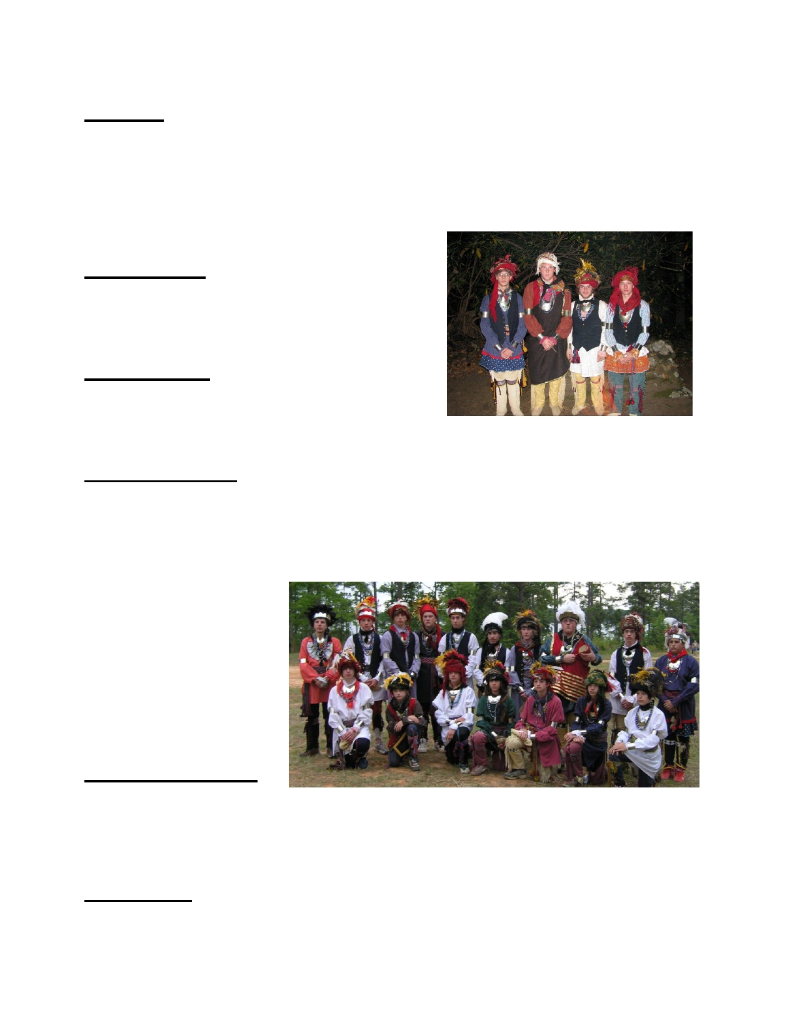
Opportunities to Serve
Elangomats
Elangomats provide examples to candidates of the Order of the Arrow during the Ordeal. They
undergo the Ordeal voluntarily to show the new members what it means to be a member of the
Order of the Arrow. The Elangomat also serves as a friend and coach to the New Member after the
Ordeal, and for at least the next 10 months. The Elangomat calls the New Member periodically to check on his progress as an Arrowman and keeps him abreast of Chapter and Lodge activities. He
encourages his Scouting Unit, but he also encourages Chapter and Lodge service and his membership conversion to the Brotherhood.
Ceremonies Team
Youth members of the Ceremonies Team can be
Principles, Seconds for Principles, Torchbearers, or
other helpers. Adult members may be coaches or helpers.
Lodge Committees
There are plenty of available positions in the lodge's various committees for both chairmen and advisers.
Committees function under the Vice-Chiefs and having somebody in charge of and advising each committee would greatly help lodge organization and operation.
Dance and Sing Teams
Members have the opportunity to participate in the lodge's Indian Dancing team, as well as
individual dancing. The group dance team uses authentic Cherokee Indian Regalia, and if you
dance individually, you get to design your own outfit for competition. You can make your own
original dance steps, and you can choose how to make your outfit. Each dance style has guidelines for outfits, but the majority of individual dancing is personal preference. Adults can assist youth by
being dance mentors or by helping out at our various
regalia workshops held
throughout the year. We have formed a drum and sing team for competition, so you could
also be a part of that if
dancing is not quite your thing.

OA Troop Representative
If you are interested in
representing the Order of the Arrow within your troop and your troop within the OA, talk to your Senior Patrol Leader about being your Troop's OA Representative. You can encourage others in
your troop to participate in OA events and take important roles. You also will help your unit leaders to arrange troop OA elections to bring new members into the lodge.
Chapter Officer
Each Chapter elects a chapter chief at Fall Fellowship. The chapter chief coordinates the activities
of the chapter, utilizing OA Troop Representatives and appointed committees: to encourage
continued lodge membership and brotherhood conversion; to carry out chapter service projects; to
hold troop elections and camp promotion; communicate within the chapter to encourage participation in lodge events.
- 18 -

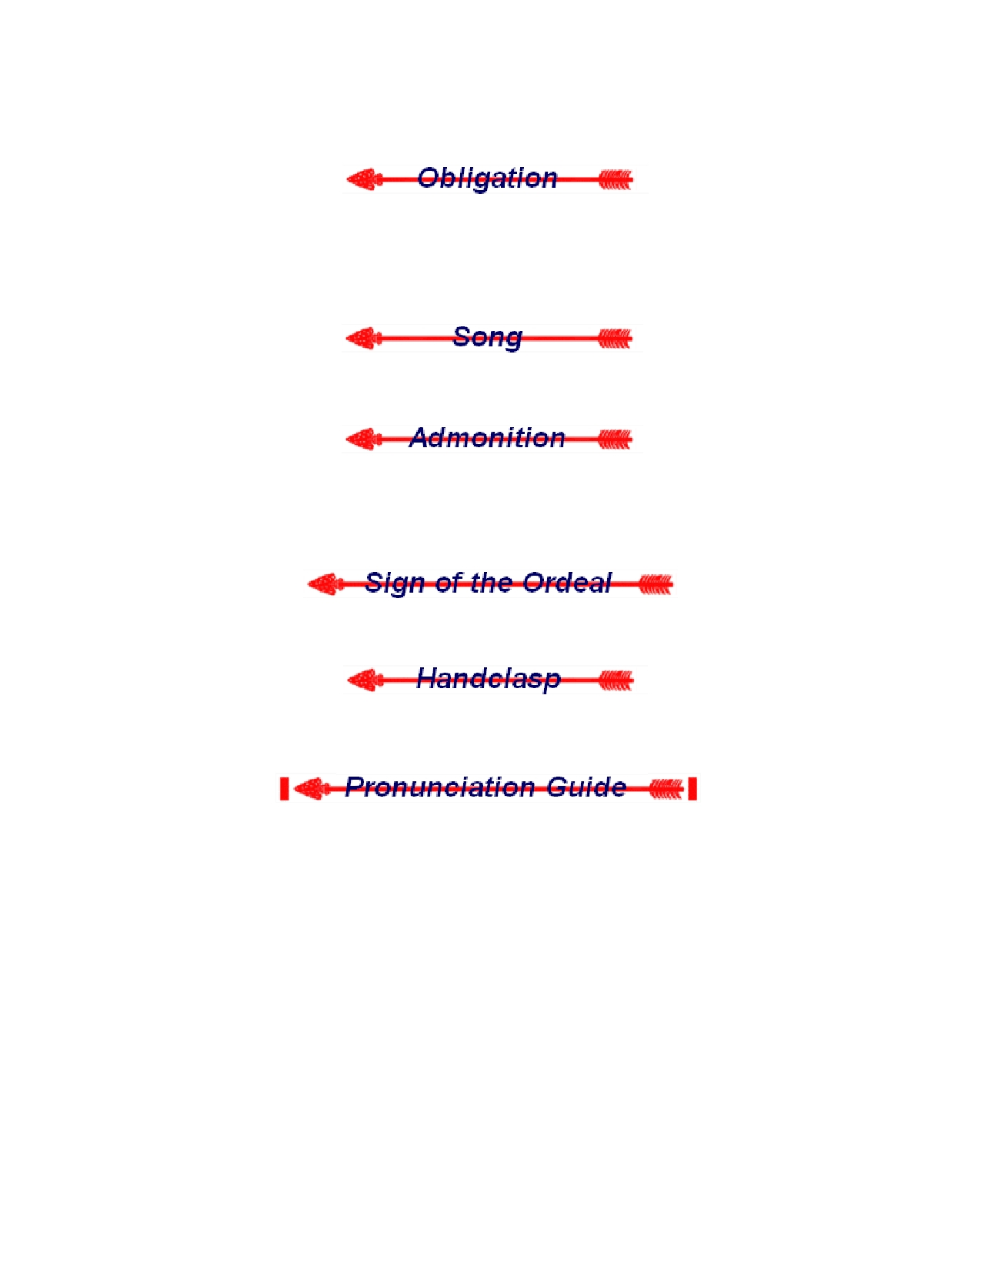
New Members Information
New Members, also read the following section on Brotherhood membership.

I do hereby promise on my honor as a scout that I will always and faithfully observe and preserve
the traditions of the Order of the Arrow, Wimachtendienk, Wingolauchsik, Witahemui. I will
always regard the ties of brotherhood in the Order of the Arrow as lasting, and will seek to preserve a cheerful spirit, even in the midst of irksome tasks and weighty responsibilities, and will endeavor, so far as in my power lies, to be unselfish in service and devotion to the welfare of others.

Firm bound in brotherhood, gather the clan that cheerful service brings to fellow man. Circle our council fire, weld tightly every link that binds us in brotherhood, Wimachtendienk.

The admonition of the Order of the Arrow must always be given whispered in the right ear; with it's
meaning then whispered in the left ear. The admonition must never be spoken aloud, and may not
be printed in text or written, with the exception of some official Order of the Arrow documents. As it is, it cannot be printed in this book.

As Allowat Sakima describes it in the Ordeal ceremony, "The hailing sign of the ordeal is made
with the right hand over the left shoulder, moving as if drawing an arrow from a quiver."

The handclasp of the Order of the Arrow is given with the left hand, as in the scout handshake, but
with the fifth fingers, or "pinkies", intertwined. It is difficult to perceive at first, but it works.

Allowat Sakima
Chingachgook
Elangomat Kichkinet
Lenni Lenape
Meteu
Nutiket
Uncas
Wimachtendienk
Wingolauchsik
Witahemui

Al'-lo-wot Sa-kee'-ma
Ching'-gatch-gook
Ee-lan'-go-mat
Kitch'-ken-et
Len'-nee Len-ah'-pee
Mee-tay'-o Nu-te'-ket
Un'-cuss
Wee-mok'-ten'-dee-enk
Win'-go-louch-sick Wi'-tah-hem'-oo-ee

- 19 -

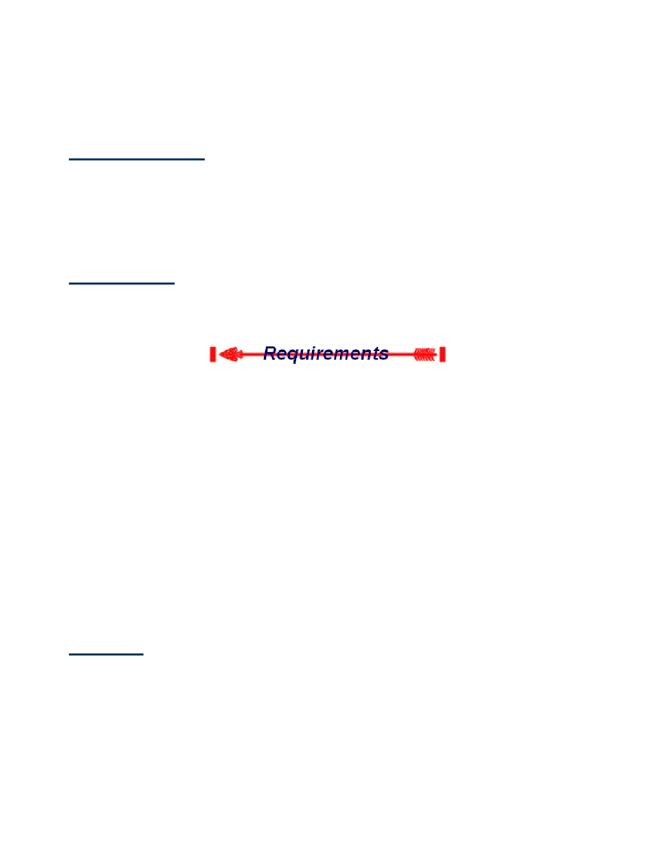
Brotherhood Membership

This page provides background information for Ordeal members interested in sealing their membership in
OA through Brotherhood conversion. It sounds like a lot, but many members have done all the requirements while at a fellowship.

Why Brotherhood?

It is said, "In the Ordeal, the Order of the Arrow accepts the new member. In the Brotherhood, the
individual accepts the lodge and the ideals of the Order." As an Ordeal member of the lodge, service to the troop is of utmost importance. Brotherhood membership in the lodge can be attained after completing ten
months as an Ordeal member, and gaining an understanding of the lodge program. Advancement to
Brotherhood membership is a personal decision, and we recommend that you look over the information on
this page, and then refer to your Order of the Arrow Handbook for further detail.

Where/When?

Brotherhood Enrichment Classes and Ceremonies are held at Spring and Summer Ordeals, Fall Fellowship, & Spring Fellowship.

Be an Ordeal member for at least ten months. Be an active member of your Scout unit.
Be an active, paid member of Tsali Lodge. Write a letter to the Lodge Secretary.
Participate in a Brotherhood Enrichment class and Brotherhood Ceremony. Know the signs that show your membership within the Order of the Arrow:

• The Obligation (p. 10, OA Handbook)
• The Admonition
• The OA Song (p. 13, OA Handbook)
• The OA Handclasp (p. 27, OA Handbook)
• The Sign of Ordeal Membership

To gain a better understanding of the Ordeal, review the questions found on pages 52-54 of the Order of the
Arrow Handbook

Once you have reviewed the above items, thought about what you have learned, done, and planned to do, write a letter to the Lodge Secretary.

The Letter

Once you feel prepared to attain Brotherhood Membership, you must write a letter to the Lodge Secretary
that includes the following:

Explain what you think the Obligation means.
Describe how you have been fulfilling this obligation in your troop and in your daily life, and how you have used your understanding of the ordeal to aid in this service.
Describe your specific plans to give service in the lodge program.

- 20 -

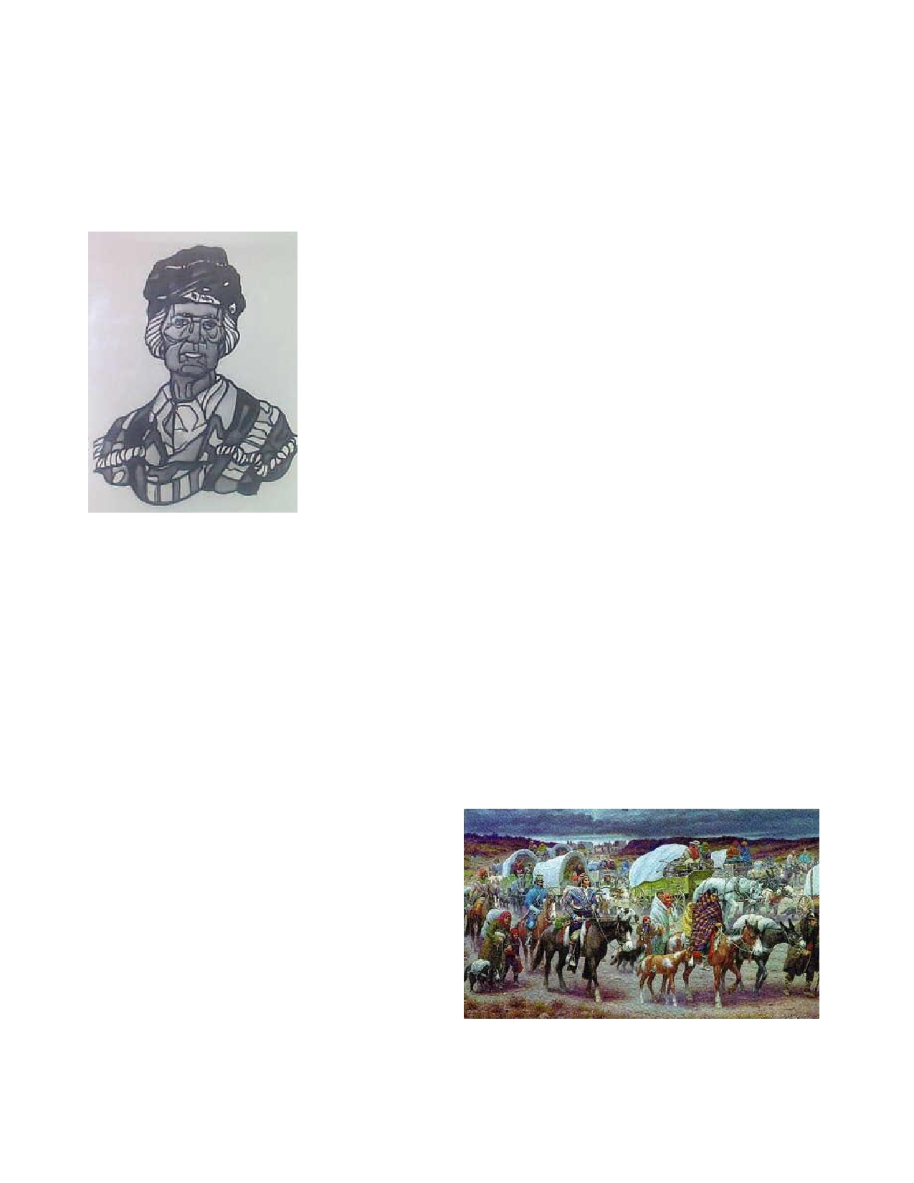
The Cherokee Legend of "Tsali"
By Lowell Kirk
Under the terms of the fraudulent 1836 Treaty of New Echote, all Cherokee who lived within the
Cherokee Nation were required to give up their homeland and remove west of the Mississippi River
to Indian Territory. As of May 1838, only a few had done so. General Winfield Scott arrived at
Calhoun, Tennessee in command of about 7,000 soldiers to forcible remove almost 16,000
Cherokee to the west. More than 25 stockades were established in
North Carolina, Tennessee, Georgia and Alabama to be used as "holding pens" for the Cherokee until they could be marched to
Rattlesnake Springs. From there, they would begin the forced march under armed escort known as the Trail of Tears.

Tsali was one of the "traditionalist" Cherokee who had not been
involved in the heated debates over the removal policy. He lived with
his wife and three sons in a cabin near the mouth of the Nantahala
River, where it flows into the Little Tennessee, near present day Bryson City, North Carolina. After an 1819 treaty, he, as well as
about l000 other Cherokee at Quallatown, lived outside the
boundaries of the Cherokee Nation. Like most of the North Carolina
Cherokee, he had been somewhat bypassed by the "progress" that had
been made by those Cherokee who had accepted the "white man's"
road after 1794. Most of the "Progressive" Cherokee lived in Georgia, Tennessee and Alabama.
Most of the Cherokee who lived in the mountains of Western North Carolina were "traditionalists."

Tsali farmed a small hillside plot and hunted to provide for his family. Only now and then did an
occasional bit of news about the troubles in Georgia trickle into this area of North Carolina. When
the Federal troops began rounding up the Cherokee in May of l838, it would be the primitive or "traditionalists" in North Carolina who made up the bulk of the Cherokee who refused to go to
Oklahoma. They had always been outside the mainstream of Cherokee "progress", and did not live
within the boundaries of the Cherokee nation as it existed from 1819 to 1838. As the historical events of l838 began to unfold, Tsali would become a legendary hero to the Cherokee.

When James Mooney of the Smithsonian Institute lived with the Cherokee from 1887 to 1890, this is the story he was told. Tsali's brother-in-law came to Tsali's cabin in May of 1838 and told Tsali
of the 7,000 soldiers who were rounding up the
Cherokee to take them to a land where the
setting sun bent down to touch the earth. General Winfield Scott had said that all Cherokee people must begin the long march west before the next
new moon. Tsali did not understand why the
Cherokee must go, and he only thought of it for a few moments as he sat by the fire puffing his
pipe. The next day he went back to his fields, with little more thought of it. And while Tsali
worked his fields, the soldiers were rounding up
the Cherokee and putting them in the more than 25 stockades, in preparation for the long march
west. Some Cherokee believed that Tsali began dreaming of a dream of how his people might stay
in their native hills. After all, that is the stuff of legends. But it is most likely that Tsali was only concerned for his crops and a good harvest to feed his family through the long winter.

- 21 -

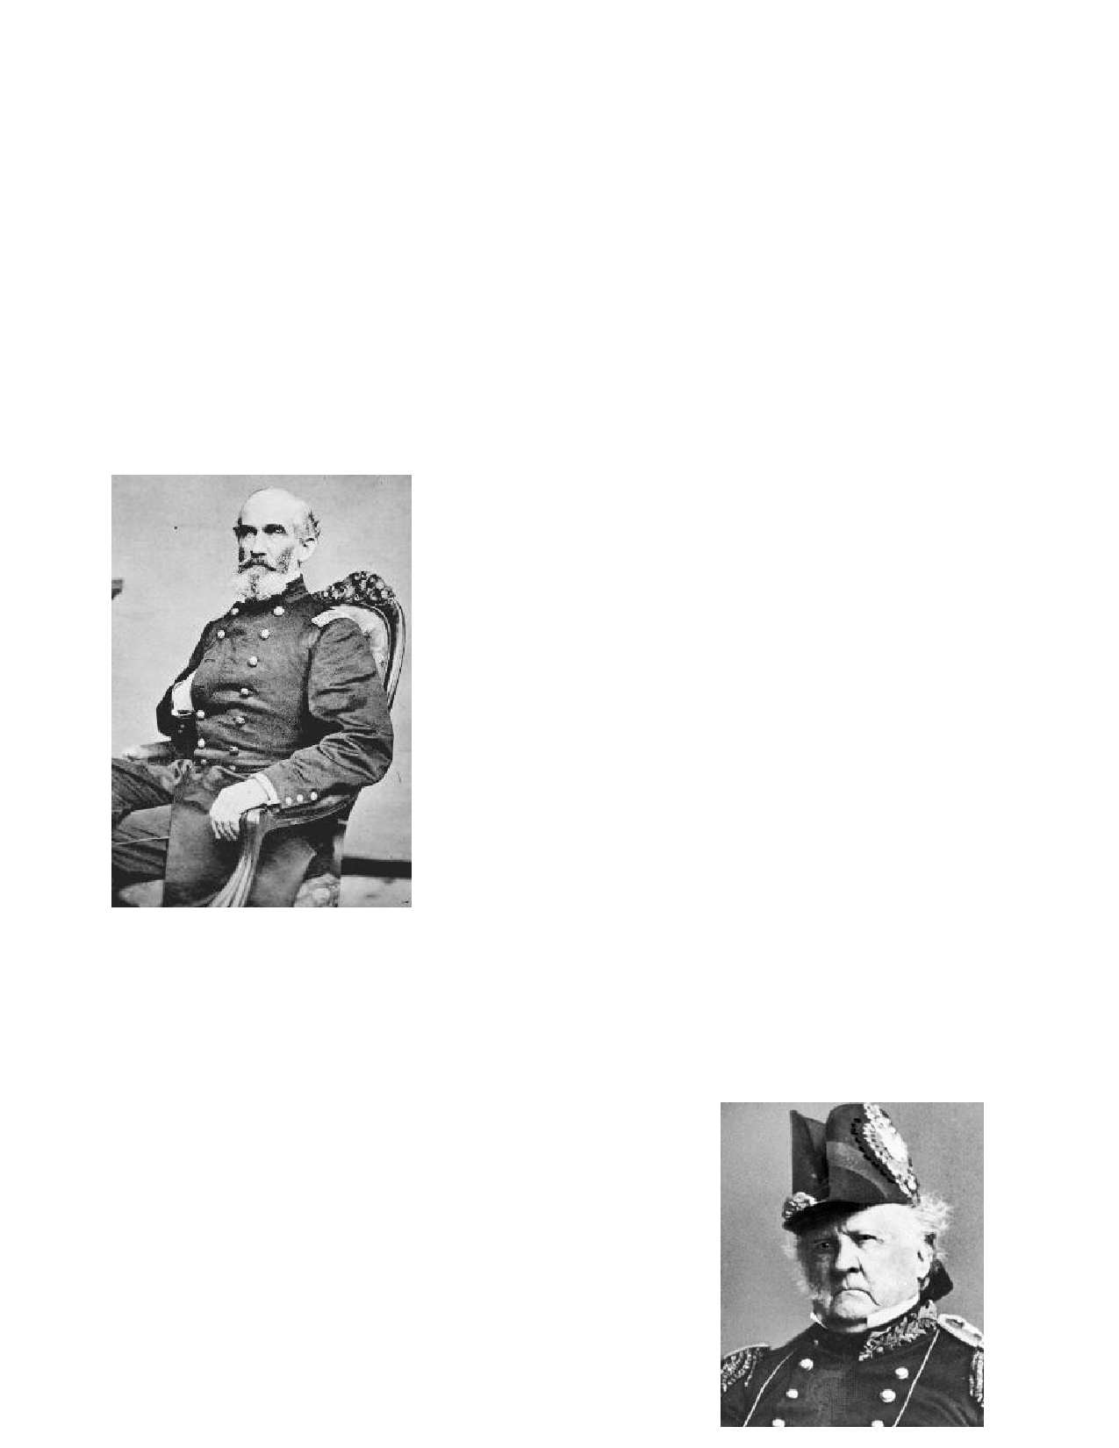
Soon the soldiers arrived at Tsali's cabin and told him that he and his family must go to the
stockade at Bushnell, down the Little Tennessee River from Tsali's cabin. The site of Bushnell is now covered by the waters of TVA's Fontana Lake. Although Tsali did not understand, he offered
no resistance. With his wife, his sons and his brother-in-law's family, they headed toward the
Bushnell stockade carrying only a few things which they had managed to put into bundles. Four soldiers escorted them. According to the story which was told to Mooney, somewhere along the way, one of the soldiers prodded Tsali's wife with a bayonet, to quicken her steps. Tsali became
angry. In the Cherokee language, Tsali told the other Cherokee to get prepared to take the soldier's
guns when he pretended to fall, and they would escape into the hills. In the resulting scuffle, a
soldier's gun discharged and ripped a hole in the side of his own head. Tsali had intended no
bloodshed, but his family quickly ran into the woods and proceeded to a cave in the mountains under Clingman's Dome.

(Second Lieutenant Andrew
Jackson Smith pictured below)
U.S. Military records give another version of the story. Second
Lieutenant Andrew Jackson Smith, accompanied by three
soldiers, had captured the Tsali group of twelve, five men, seven women and some children. In the morning of November l, Smith led the "prisoners" back toward the stockade at Bushnell.
Having made a camp, Smith warned his men to be on guard for trouble. Shortly thereafter, one of the Cherokee drew a hidden ax and sunk it in the forehead of one of the three soldiers. In the
next moments, a second soldier was killed, and the third was
wounded. Smith claimed that his horse became frightened and ran away, saving Smith's life, according to his official report.
The Cherokee then fled, after taking some articles from the
soldiers. Smith went to the Bushnell stockade, took the Cherokee who had been previously collected there and marched to Ft. Cass
at Calhoun where he made his official report to Gen Scott on Nov 5.

This brings up a question. How could four United States military
personal, carrying rifles, one on horseback when they were supposedly camped, be overpowered by
five Cherokee men and seven women and children, who were apparently armed with only one ax
small enough to be hidden on a man's body? In Lt. Smith's report there was no mention of a soldier
prodding Tsali's wife with a bayonet. However, what United States "officer and a gentleman"
would report to his superior that one of his soldiers prodded an old woman with a bayonet, if it had happened as the Cherokee story related.
(General Scott pictured below)
On November 6, General Scott gave orders to Colonel William S.
Foster to hunt down and shoot the "murderers." Foster was
ordered to "collect all, or as many as practicable, of the fugitives (other than the murderers) for emigration." The aid of Drowning
Bear and Will Thomas was enlisted. Thomas was the white
adopted son of Chief Drowning Bear of the Quallatown band. As the Quallatown Band lived outside of the Cherokee Nation, they
were not required by law to emigrate. Thanks to Will Thomas General Scott made a distinction between the Quallatown Band living near the Oconaluftee River and "fugitives". Thomas had
convinced General Scott that the Quallatown Band had promised
- 22 -

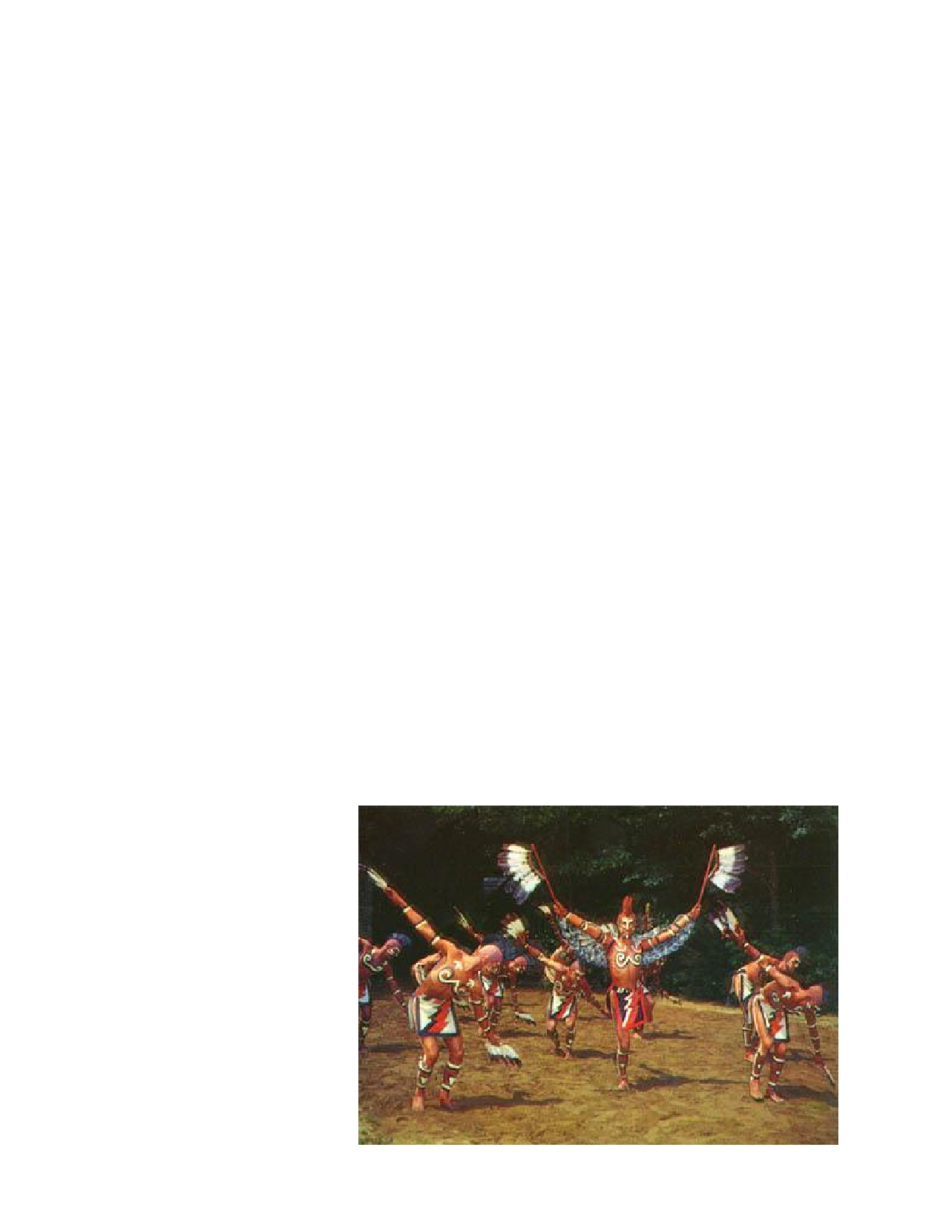
not to hide any of the "fugitives", referring to those who had fled from their homes within the
Cherokee national boundaries. Even John Rose, Chief of the Cherokee Nation, sent his condolences to General Scott for the murders, saying that the Cherokee Nation should not be held responsible for
this "individual" occurrence. Colonel Foster entered the upper Little Tennessee country with nine
companies of the U.S. Fourth Infantry. A tenth company had proceeded toward the Oconaluftee
with Will Thomas, under the command of Lieutenant Larned. Apparently, Thomas convinced the
Quallatown Cherokee that if they would help catch Tsali and the other "murderers," they would be allowed to stay in North Carolina.

So the Oconaluftee Cherokee provided a total force of about sixty men to capture the "murderers,"
when ten companies of U.S. troops could not! Soon the Cherokee turned over to Colonel Foster
Tsali's oldest son, Nantayalee Jake, and Tsali's brother-in-law, Nantayalee George, whom Foster claimed were the "principal actors in the murder." Tsali's wife and the wife of Nantayalee George and her small daughter had also been brought in by the Oconaluftee Cherokee. By November 24,
Foster reported that of the twelve Cherokee present at the murder site, all but Tsali had been
captured. Three adult males were executed. The Cherokee themselves made up the six man firing
squad. Tsali's youngest son was spared, along with Tsali's wife. Colonel Foster announced that
removal had officially ended and the rest of the Indians in hiding could join their brothers at
Quallatown, on the Oconaluftee. Will Thomas had convinced Foster that Tsali had played only a
minor role in the affair, and so Foster's Fourth Infantry left the mountains, their mission complete. After Foster had left Bushnell, Tsali was brought in by other Quallatown Cherokee. At noon on the next day, Tsali was tied to a tree and shot in the same manner as the other three.

Colonel Foster's final report on the affair, dated December 3, l838 reported Tsali's execution, and commended Drowning Bear for his assistance. Foster also asked that one of the "fugitive" groups
under the leadership of Euchella, who had helped in the capture of Tsali, be allowed to stay with the Quallatown Cherokee. The commissioners for the Cherokee removal officially agreed to allow such in January, l839.
Soon, the story of Tsali became a legend and inspiration among Quallatown Cherokee. It was widely reported that Tsali had willingly surrendered so that the Federal troops would leave the
North Carolina mountains and allow the Quallatown Cherokee to remain in their ancient homeland. Although the Federal government had declared that the removal was over, for the rest of the century the government continued to make efforts to get the Quallatown Cherokee to emigrate to the west. It
was the legend of Tsali, and the belief that he had selflessly given his life in order that some of his
people could remain in their
beloved mountains. In the hearts
and minds of the Cherokee
people today, Tsali still lives! And so do more than 10,000
Cherokee today, in the center of their ancient homeland.

- 23 -

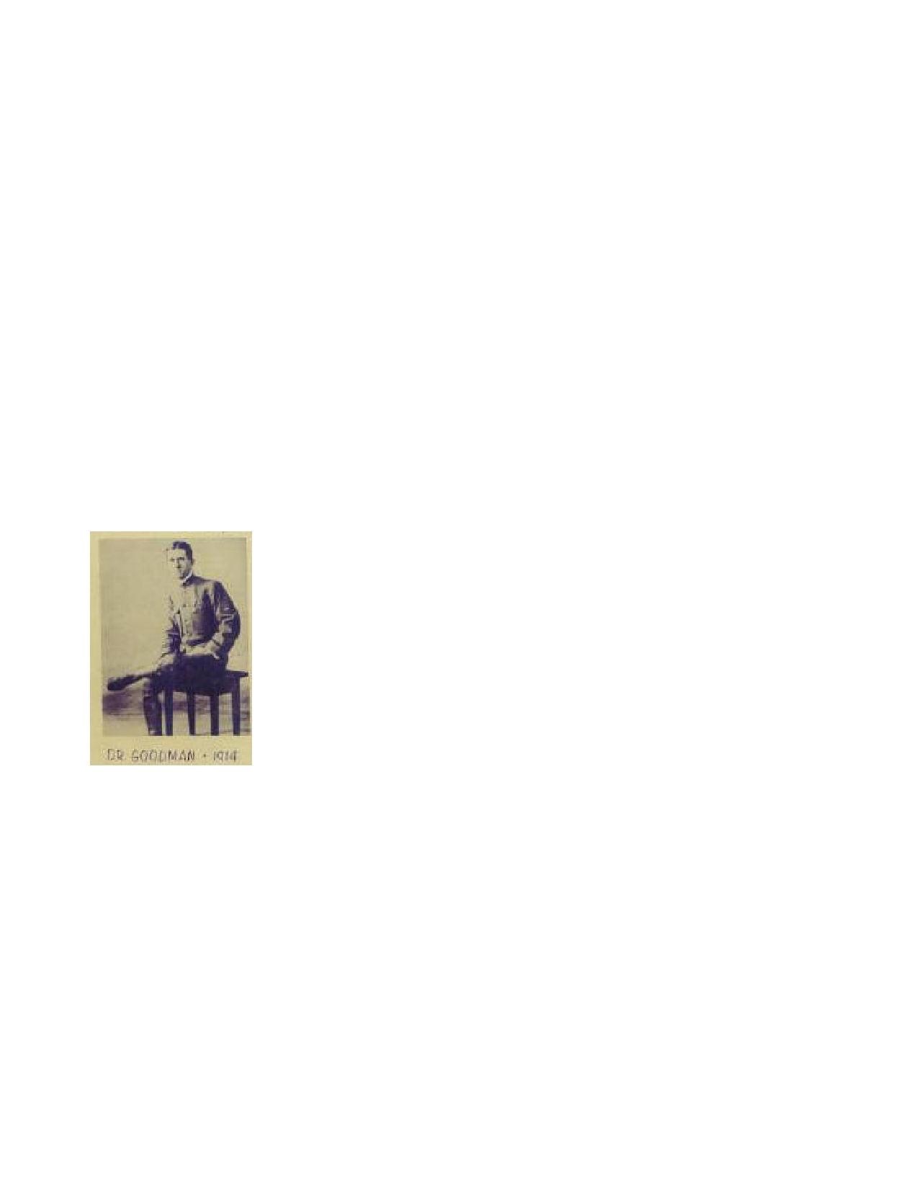
Order of the Arrow History

THE "ORDER OF THE ARROW" - SCOUTING'S HONOR SOCIETY
by Jim Howes

The Order of the Arrow is a recognized official program activity of the Boy Scouts of America,
intended to recognize those scouts who best exemplify the scout virtues of cheerful service, camping, and leadership.

Founded in 1915, just seven years after the acclaimed English war hero Robert Baden-Powell
started scouting in Great Britain, the Order of the Arrow is the uniquely American "honor society of scouting". The "OA's" origin and development are tightly intertwined, like a well-made square knot,
with scouting itself in the United States. Its history is a remarkable saga of a good-hearted visionary's effect on many generations of youth.

The new scout movement was enjoying halcyon days in an America still at peace in 1915, while
young men in Europe were dying by the thousands in a war more terrible than any before in history.
Boys in the U.S. seemed to be donning scout uniforms everywhere as membership grew rapidly
from coast to coast. Prominent businessmen, civic and religious groups, and politicians, including
Congressmen and the President, vied to match the enthusiasm of boys
surging into scout camps across the nation, eager to be part of the great wave
of scouting which had reached American shores in the years before World War I.

As E. Urner Goodman, then a 25 year old scoutmaster, walked along
Chestnut Street in downtown Philadelphia, PA, in May, 1915, he heard newsboys hawking the Philadelphia "Inquirer's" headlines, blaring the
sinking of the Cunard oceanliner "Lusitania" hit by a U-boat's torpedoes within view of the Irish coast. Urner was busy with plans that would also
have far reaching effects, for he had agreed to take the job of Camp Director
at the Philadelphia scout council's camp perched on idyllic Treasure Island
in the Delaware River. What he had in mind was to leave a lasting imprint on thousands of American youth in the twentieth century.

Urner's thoughts in 1915 were focused on development of methods to teach the scouts attending
summer camp that skill proficiency in Scoutcraft was not enough; rather, the principles embodied in
the Scout Oath and Law should become realities in the lives of Scouts. As a means of
accomplishing this without preaching and within a boy's interest and understanding, he decided to
launch an innovative program that summer based on peer recognition and the appeal of Indian lore.
Troops would choose, at the conclusion of camp, those boys from among their number best exemplifying these traits, who would be honored as members of an Indian "lodge". Boys so
acknowledged in the eyes of their fellow scouts would form a fraternal bond joined together in a richly symbolic brotherhood.

Assistant Camp Director Carroll A. Edson helped Urner research the lore and language of the
Delaware Indians who had inhabited Treasure Island, which they combined with characters from
James Fenimore Cooper's "Last of the Mohicans", to develop dramatic induction ceremonies for the
"Order of the Arrow", as the fledgling honor society was dubbed. Even today, these rites make a lasting impression on scouts who have been elected to the "Order of the Arrow".
- 24 -

By 1921, the idea had spread to a score of scout councils in the northeast and the first national
meeting of the Order of the Arrow was held. Although the OA was initially viewed with suspicion
by some Scouters as a secret society, if not an affront to the egalitarian ideals of scouting, legendary Chief Scout Executive James E. West permitted those councils desiring Order of the Arrow lodges to establish them as an "experimental" program under a "National Lodge". Not until 1948 was E. Urner Goodman's innovation fully integrated into the Scouting program.

Having observed its Diamond Anniversary in 1990, membership in the Order had grown to 160,000
of the one million eligible Boy Scouts in the U. S., organized into almost 400 lodges nationwide.
Rare indeed is the council today that does not have an Order of the Arrow lodge with its own Indian name and "totem", or emblem.

It is evident that the Order of the Arrow has made a significant contribution to Scouting, as we
know it today in the United States. The OA's motto, "Brotherhood of Cheerful Service", is more
than just an empty slogan for many Arrowmen, who constitute a valuable council resource for camp
promotion, improvement projects, and summer camp staff. The OA, at its best, continues to be a powerful teaching tool for Scouting ideals.

The OA helps in retaining older boys in Scouting, who otherwise often
tend to lose interest upon reaching high school age. Notably, OA
guidelines place great importance on preserving Lodge leadership in the
hands of its youth members, headed by a Chief, Vice Chief(s), and an
Executive Committee, all of whom must be under age 21, who plan and implement Lodge activities, service projects, ceremonies, publications, budgets, and conduct troop elections as arranged with Scoutmasters. In
larger councils, lodges are often sub-divided into "chapters", with youth chapter officers and
committeemen running chapter events. At the Section, Regional, and National levels, Chiefs and
Vice-Chiefs are typically young men of college age, since Arrowmen are considered youth members until age 21.

Adults are crucial to the OA's success as advisers and resources, such as transportation, service project skills, and the like. Many adult Scouters find participation in the OA to be rewarding, as they help kindle anew the spirit of brotherhood in scouting's honor society.

To be inducted into the Order of the Arrow, a Scout must:

• Be at least First Class rank;
• Have at least 15 nights of camping, including a 6-day long-term camp;
• Participate in the "Ordeal" and induction ceremony, after election by his Boy Scout troop or
Varsity unit.

Each Scout troop may schedule an Order of the Arrow election once annually. All registered active
youth troop members have a vote, both current Arrowmen and non-Arrowmen. Membership selection is thus predominantly by non-members.

Adult Scouters may be proposed for membership in the Order of the Arrow by unit or district committees or the Lodge. Once selected, they, too, undergo the "Ordeal" and participate in the induction ceremonies.

To alleviate lingering concerns in some quarters regarding the ceremonial aspects of the Order of
the Arrow, the BSA has officially stated:
- 25 -

"The induction is not a hazing or an initiation ceremony. The Order is not a secret Scout
organization, and its ceremonies are open to any parent, Scout leader, or religious leader. There is an element of mystery in the ceremonies for the sake of its effect on the candidates. For this reason, ceremonies are not put on in public. The ceremonies...are not objectionable to any religious group."

Following 10 months as an "Ordeal" member, the Arrowman may participate in the "Brotherhood" ceremony, which signifies the sealing of his membership and an additional emphasis on OA ideals and purposes.

After an additional 2 years have elapsed, exceptional OA leaders may be recognized by conferring
of the "Vigil Honor". Generally speaking, only two percent of the Lodge membership may be
selected each year for this highest of Lodge honors. A special ceremony, devised by Dr. Goodman in 1915 and closely based on ancient Indian traditions, culminates this experience.

All Order of the Arrow members are reminded that their primary duty always remains to their own
troop, which elected them in the first place as a result of their cheerful service to their fellow unit members. OA Lodge activities are intended to SUPPLEMENT, and not REPLACE, troop activities.
Probably the single most often-heard complaint directed towards the OA program is that of Arrowmen who have forgotten this cardinal principle.

OA Lodges meet with other lodges in their sections each year and attend a nationwide gathering held on the campus of a major university every 2 years. These National Conferences, as they are
called, feature individual and Lodge competitions in ceremonies, Indian dancing and costumes, and
sports, along with seminars and gala arena shows. More
than 6,000 Arrowmen attend, which for many is an
exciting highlight of the scouting experience on a par with a National Jamboree.

For over a half century after founding the Order of the Arrow, E. Urner Goodman continued to be a towering
figure in American scouting, attaining a doctorate in
education and becoming National Program Director of the
BSA for many years, all the while steadfastly devoted to
the OA. He enjoyed meeting Arrowmen at his Order of the
Arrow "lodge" home in Vermont and continued to attend events held by Unami Lodge #1 in Philadelphia for the rest of his life.

Dr. Goodman's keynote speeches were a traditional and inspiring highlight of OA National
Conferences, until his final appearance in 1979 at Colorado State University, just six months before his death at 89. He was hailed by the 4000 Arrowmen present with a thunderous standing ovation. He spoke movingly of his creation of the OA as a "Thing of the Spirit" in that place ... so distant in time... on the misty shores of the Delaware River. He bade us farewell, there in the shadows of the snow-capped Rockies, with a memorable peroration to keep the OA's flame of fellowship glowing brightly in our hearts. Though a frail, elderly man stood before us, stooped with age, yet the spirit
borne within would truly live on in our hearts, firm bound eternally in youthful brotherhood, wherever men strive to love and serve one another.

© Atlas Communications. All rights reserved.
Used by Tsali Lodge with permission from the author

- 26 -

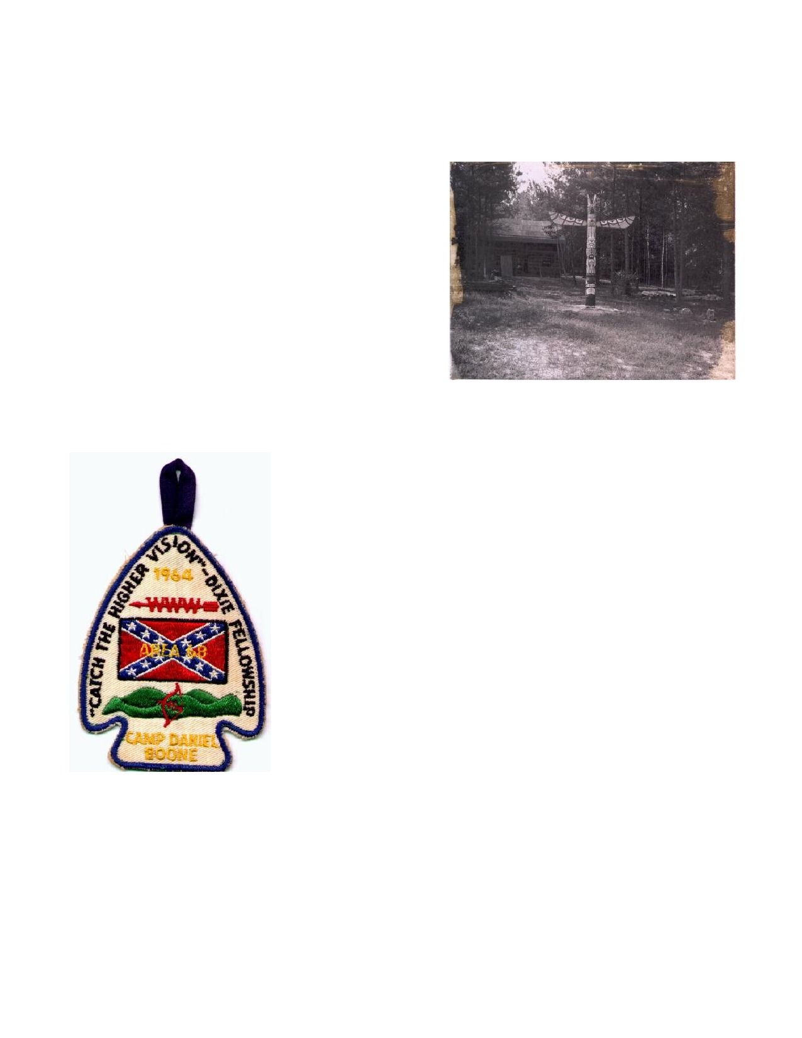
Timeline History of Tsali Lodge
1938...
▪Arrowmen of Bobwhite Lodge 87 in Augusta, GA help charter Tsali Lodge 134 of Daniel Boone
Council in Asheville, NC. The Lodge was named after the Cherokee Chief Tsali who
sacrificed his own life so those of his people
could remain in the Appalachian Mountains. Web Stacey, the Lodge's first chief takes office.
1940...
▪It is said that arrowmen from Tsali help found Atta
Kulla Kulla Lodge 185 of Blue Ridge Mountain Council in Greenville, SC.
1949...
▪William Roth becomes the first Arrowman of Tsali
Lodge to receive the Vigil Honor and is given the Vigil name of "The Great Warrior".
1954...
▪August 27: William Roth becomes the first arrowman of Tsali Lodge to receive the Distinguished
Service Award (DSA) at the 1954 National Order of The Arrow Conference at The University of Wyoming.
1964...
▪April 24-26: Tsali Lodge hosts the 1964 Dixie Fellowship "Catch
the Higher Vision" at Camp Daniel Boone. The 1964 Dixie
Fellowship would be the first conclave that the Lodge hosted.
▪Richard Hurley becomes the first arrowman of Tsali Lodge to hold
the office of Section Chief of Area 3B. (Called Area Chief during
this time)
1981...
▪April 24-26: Tsali hosts the 1981 Dixie Fellowship "Scouting, A
Thing of The Spirit" at Camp Daniel Boone.
▪Lodge member Walter Dean becomes the Section's Vice Chief of Administration while Jack Cole Becomes the Section Dixie Chief.
1982...
▪Tsali Lodge Member, Walter Dean is re-elected Section Vice-Chief
of Administration and Mark O'Shields becomes the Section Secretary.
1983...
▪Jeffrey Grey and Carmer Bean become the first youth and adult arrowmen of the Lodge to be
presented with the Founder's Award at the Lodge Winter Banquet.
1984...
▪To promote service, the lodge issues a special silver bordered lodge flap to those who completed
100 hours of service.
1985...
▪Lodge arrowman, David Kafitz is elected Section Secretary.

- 27 -

1988...
▪April 22-24: Tsali hosts the 1988 Dixie Fellowship "Weld Tightly Every Link" at Camp Daniel
Boone.
▪Tsali celebrates its 50th Anniversary. A commemorative patch is issued for the occasion.
▪To become historically correct, the "Smoke and Teepees" from the current lodge flap are omitted.
(Cherokee Indians did not live in teepees)
1989...
▪David Kafitz is elected Section Chief and presides over the 1989 Dixie Fellowship "Aim High,
Serve Y'all" at Camp Ho Non Wah in Charleston, SC.
1992...
▪Tsali Lodge hosts the Section Indian Seminar at Camp Daniel Boone.
▪Tsali provides guides to help with Kituwah, a large Native American Expo held at the Asheville
Civic Center.
1993...
▪Tsali helps with Kituwah for a second year in a row.
1994...
▪Bernie Grauer is elected Section Secretary.
▪John Young is presented with the Distinguished Service Award at the 1994 NOAC, held at Purdue
Univ.
▪Tsali provides assistant guides for the Kituwah for a third year in a row.
1995...
▪The warehouses which the Native American Expo Kituwah stored it's supplies is destroyed by
fire...the event is cancelled until 1998.
▪Tsali Lodge helps Daniel Boone Council with the selling of Christmas Trees for a fundraiser.
1997...
▪Tsali Lodge hosts the annual Section Retreat "Rekindling Old Flames" at Camp Hope.
▪Gavin Douglas is elected Section Vice-Chief of Program.
1998...
▪Due to extensive flash flood damage to Camp Daniel Boone, Tsali is forced to give up the hosting
of the 1998 Dixie Fellowship.
▪Tsali celebrates it's 60th anniversary. A limited issue patch is issued for the anniversary.
▪Tee Pruitt is elected Section Chief and presides over the 1999 Dixie Fellowship "Cheerfully
Serving Into The 21st Century" at Camp Old Indian in Greenville, SC. ▪Gavin Douglas is re-elected Section Vice-Chief of Program.
▪Tsali sends it's first official contingent to the annual Carolinas Indian Seminar in Statesville, NC.
1999...
▪Jason Laney is Elected Section Secretary.
▪Todd Knaperek is appointed Section Indian Affairs Coordinator for the 2000 Dixie Fellowship.
2000...
▪April 14-16, Tsali hosts the 2000 Dixie Fellowship "Your Journey Is Just Beginning" at Camp
Daniel Boone.
▪Jason Laney is elected Section Chief and presides over the 2001 Dixie Fellowship "Remember the
Past, Serve the Future" at Camp John Barnhardt in Albemarle, NC.
▪Tee Pruitt is presented with the Distinguished Service Award at the 2000 NOAC at The University
of Tennessee, Knoxville.
▪Lodge Member Tee Pruitt helps create the Arrowmen of Service Award.

- 28 -

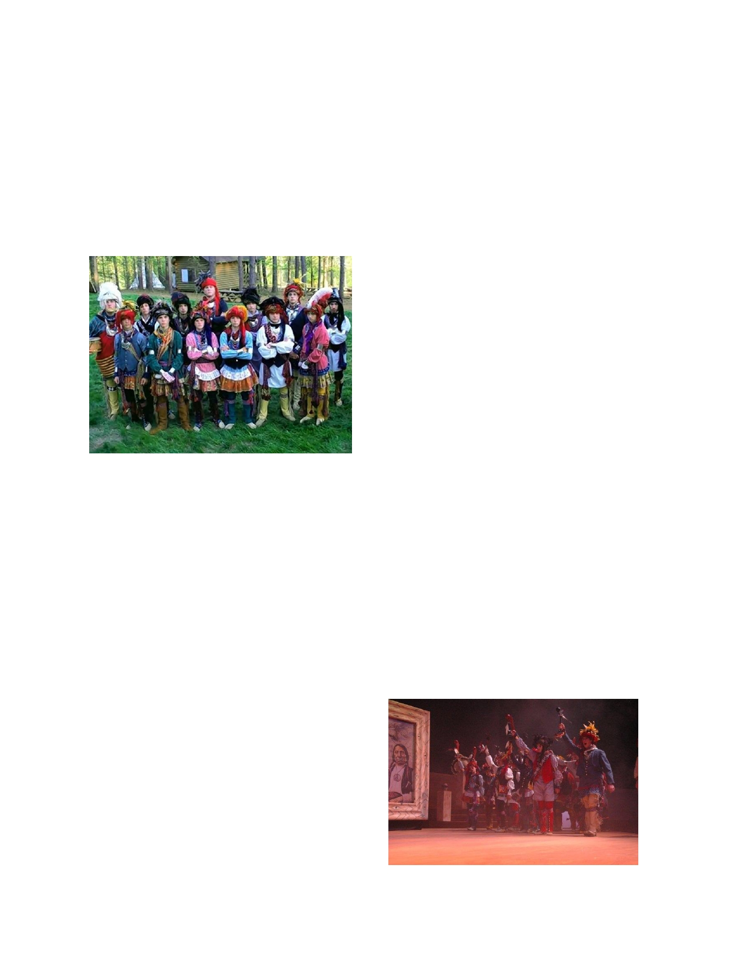
2001...
▪January 16-Lodge officially launches www.tsalilodge.org as the Lodge's official website.
▪William Barry is appointed Administrative Events Coordinator for the 2002 Dixie Fellowship in
Charleston, SC
2002...
▪The lodge begins to build a new ecology lodge at Camp Daniel Boone.
▪Jason Laney is awarded the DSA at the 2002 National Order of the Arrow Conference.
2003...
▪Tsali is chosen to be the official service lodge of the OA Indian Summer to be held at Ridgecrest
Conference Center in Black Mountain, NC.
2004...
▪Tsali lodge helps rebuild Camp Daniel Boone after
massive flooding in the fall of 2004, the result of two back-to-back hurricanes.
2005...
▪Tsali lodge develops a Cherokee style dance team
and competes at Dixie Fellowship, placing third. ▪Tsali lodge conducts a southern drum seminar,
taught by Bo Limbaugh. A Tsali Lodge drum team is then formed.
2006...
▪The Tsali lodge Cherokee Dance team places first
at Dixie Fellowship and goes on to become National Champions at the National Order of the Arrow Conference held at Michigan State University.
▪The Tsali Lodge Southern Drum team, "Twisted Rawhide" places second at Dixie Fellowship and
then third at NOAC only 6 months after being formed.
2007...
▪Adam Kuykendall is elected section vice-chief.
▪"Twisted Rawhide" sing team places First at Dixie Fellowship
▪The Tsali lodge Cherokee Dance team places first at Dixie Fellowship
▪Tsali Lodge dance team is invited to perform traditional Cherokee dances at the "Fading Voices"
gathering of the Snowbird Cherokee
2008...
▪"Twisted Rawhide" sing team places First at Dixie Fellowship
▪The Tsali lodge Cherokee Dance team places
first at Dixie Fellowship for the third year in a
row
▪The dance team performs at the Cherokee
"Fading Voices" gathering for the second year
in a row
2009...
▪"Twisted Rawhide" sing team places First at
Dixie Fellowship for the third year in a row and then became National Champions at the National Order of the Arrow Conference.
▪The Tsali lodge Cherokee Dance team places first at Dixie Fellowship for the fourth year in a row
and goes on to repeat as National Champions at the National Order of the Arrow Conference held at Bloomington, Indiana.
- 29 -

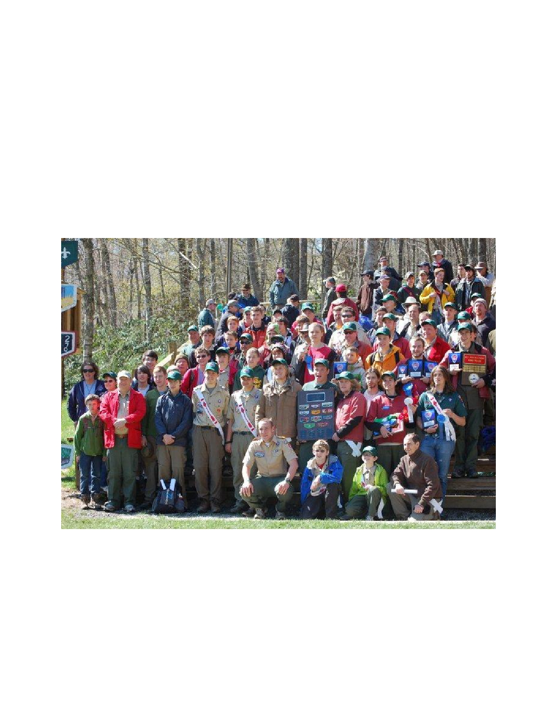
2010...
▪The Tsali lodge Cherokee Dance team wins at Dixie Fellowship for the fifth year in a row
▪The Tsali Lodge Southern Drum team, "Twisted Rawhide" wins at Dixie Fellowship for the fourth
year in a row
▪The Tsali lodge Brotherhood Ceremonies Team wins first place at Dixie Fellowship
▪ Tsali Lodge is named "Lodge of the Year" at Dixie Fellowship
2011...
▪The Tsali lodge Cherokee Dance team wins at Dixie Fellowship for the sixth year in a row
▪The Tsali Lodge Southern Drum team, "Twisted Rawhide" wins at Dixie Fellowship for the fifth
year in a row
▪Tsali Lodge is named "Lodge of the Year" at Dixie Fellowship
▪Tsali is official service lodge of the OA "Indian Summer" held at Ridgecrest Conference Center
▪James Hylemon is elected Section Chief and will preside over the 2012 Dixie Fellowship
"Gathering as one"

- 30 -

Past Lodge Chiefs
Lodge Chief Name Year(s) Served Elected Section Service

123456789
10 11 12 13 14 15 16 17
18 19 20 21 22 23 24 25 26 27 28 29 30 31 32 33 34 35 36 37 38 39 40 41 42
Webb Stacy
Marshall Gravet Vernon McCurry Albert Blackwell
Ben Edwards
Ed McClain Joe Fulmer
Ronald Kirby Ernie Hansel
Daren Hutcheson
Eddie Gash
Fleet Benning Mike Roberts Don Osborne John McLeod
David Black
David Putnam
Peter Sprague
Mike Mann
Jack Cole
Walter Dean
Jeff Grey
Bryan Claton
David Atkinson
David Kafitz George Todd
Joe Frick
Dallas Hicks
Brian McMullan
Chuck Carter Burney Mack Ryan Banning
Bill Hixson
Robbie Southern
Tee Pruitt
Jason Laney
Brian Simpson William Barry Chris Hoover
Adam Kuykendall
Scott Martin Mitchell May
1938-41 1942-43 1944-45 1946-47 1948-49 1950-51 1952-53 1954-55 1956-57
1958
1959-60
1961 1962
1963-64 1965-66 1967-68 1969-70
1971-72 1973-74 1975-76 1977-78 1979-80
1981
1982-84
1985 1986 1987 1988 1989 1990 1991
1992-93 1994-95
1995, 1996
1997-98
1998-2000
2000 2001
2002-03 2004-06
2007
2008-09

2x Section Vice Chief of Admin 81-82

Section Secretary 1985, Section Chief 1989

Section Chief 1998
Section Secretary 1999, Section Chief 2000

Section Vice Chief 2007

Section Vice Chief 2010-11, Section Chief
43 James Hylemon 2010 2011-12
44 Bryson Christy 2011
45 Cameron Barnett 2012
46 Travis Broadhurst 2013
Names that are Highlighted are at least 3 term lodge chiefs
- 31 -

Vigil Honor Roster

The Vigil Honor is a high mark of distinction and recognition reserved for those Arrowmen who, by
reason of exceptional service, personal effort, and unselfish interest, have made distinguished
contributions beyond the immediate responsibilities of their position of office to one or more of the
following: their lodge, the Order of the Arrow, Scouting, or their Scout Camp. Under no
circumstances should tenure in Scouting or the Order of the Arrow be considered as reason enough for a Vigil Honor recommendation.

The Vigil Honor is the highest honor that the Order of the Arrow can bestow upon its members for
service to lodge, council, and Scouting. It dates from the year 1915, when founder E. Urner
Goodman became the first Vigil Honor member. Since then, thousands of members have been awarded this honor.

Any member of the Order of the Arrow registered in Scouting and in good standing in a regularly chartered lodge is eligible for recommendation to the national Order of the Arrow Committee for elevation to the Vigil Honor provided that, at the time of the recommendation, the individual has been a Brotherhood member for a minimum of two years. A lodge may nominate a maximum of two percent of their registered Arrowmen once a year, through the Vigil Honor petition, found in the annual re-charter packet. At least 50 percent of all nominated must be under 21 at the time of nomination.

Year 1949

Recipient
William Roth

Vigil Name
"The Great Warrior"

1964

Ernie Hansel

"He of the Beautiful
Place"

1950 Vernon McCurry 1952 Clayton McCrackin
Francis Pless
"The Prince"
"Big Hearted One" "The Woodsman"
Richard Hurley
Minor Wilson Charles Worley
"Place of Friends"
"Feathers of All Kinds"
"Chief"

1953 1954 1955
Robert Garner Gene Cocke Carmer Bean
"Leading Chief"
"He Is a Man"
"A Leader"
1965
Eugene Hansel
Tom Harrison
Pat Mitchell
"Star"
"Strong and Mighty" "First in the Dance"

1957 William Lassiter
Thomas Speed
1959 Geoffrey Cooper
Davis Nichols
William Smith
"Standing Deer"
"Flying Messenger" "One Who Shoots" "Little Big Man" "Great Tree Top"

1966
Jerry Starnes
W.M. Vanvalkenburgh
Thomas Dillard
M. Hansel
Ronald Kirby
"Middle of the Day"
"Medicine Man" "Lightening Bug"
"Water Carrier"
"Efficient"

1960

1961

1962
Frank Biddix
Joe Fulmer
Charles Reeves
Paul Willis Paul Cabe
John Crawford
"Young Deer"
"Young Beaver"
"Handsome"
"Excell All Others"
"Squirrel"
"Peace Maker"

1967
Mike Williams
Charles Arthur
John Brown
Clarence Burrell
Daren Hutcheson
"The Traveler"
"Enchanted Lake"
"Frost Walker" "Town House"
"He of the Lookout
Place"

Gary Jensen "Water Side"
- 32 -

1968

1969

1970

1971

1972

1973
George Benning
Dan Collier
Max Hughes
James Hutcheson
C. Corbin
Ronald Edwards
William Green John Ledbetter
James Lollar
Robert McKinney
David Putnam Loren Brown
James Furr
Jimmy Garren
Eddie Gash
Johnathan Jones
James Lipe
Jamie Soesbee
Richard Stansbury
Doug Van
Valkenburgh
Timothy Wilson
J. Arden
Roger Corbin
John Daniel
Bill Dyar
Franklin Gordon
Henry Graham
Jerry Jarvis Brad Ripple Mike Roberts Bruce Arden
Robert Cansler
Robert Cook
William Edwards
Robert Gash
Richard Gustafson
Carl Haynes
David Henderson
Ralph Putnam Hank Birdsong
(Wahissa Lodge)
Jake Wilson
David Briscoe
John Cox
Robert Fisher
"The Great Bull"
"Buffalo"
"Standing in the
Center"
"All Afire"
"Humming Bird"
"Drum"
"Bee"
"I Think" "Beaver"
"He Is Fast"
"Deer" "Ruler" "Hello" "Pond" "Chief" "Lamp"
"Big Man"
"Jim"
"Doctor"
"Little Chief"
"First"
"Tall" "Bird"
"Big Bear"
"Arrow Maker"
"Night Hawk"
"Happy" "Quiet"
"Chipmunk"
"Red Fox"
"Little Tall"
"The Frogs Cry Here"
"Red Bird"
"Worker" "Old Owl" "Cherokee"
"Chief of Peace"
"Ground Hog"
"Bat"
"Bird"
"Hammer"
"Moose"
"Tree Friend"
"Standing Indian"
1973

1974

1975

1976

1977

1978

1979

1980
Emory Gash
Dan Harrison
Donnie Osborne
Charles Toms James Fender James Deavor Doug Elledge James Hatley Brent Leftwich Richard Sharpe Dennis Stockdale Donald Henderson
Thomas Massie Russell Matheson David McCartney
John McLeod Charles Pettee Thomas Wilson Lewis Blodgett
Charles Farr
Richard Hageman
Brian McKinley
Peter Sprague William Taylor Todd Dingman
3rd Furtado
Norman Harrill Robert Harrison Robert Pearson Justin Scroggs
Bill Taylor
Norman Harrill Jr.
Philip Johnson Clifford Lively Floyd Lowrance William Ratcliffe
Herman Stone Bruce Blakely
Jack Cole
Carleton Collings
Walter Dean
Chris Farr
Jeffrey Gray
David Atkinson
Thomas Atkinson
David McCurry
"Mischief"
"Dancer"
"Hungry Bear"
"Gentle One"
"Mountain Teacher"
"Cricket" "Spider"
"Hat"
"Wind"
"Turkey"
"Mountain Teacher"
"Sharp Knife" "Tall Walker" "Heavy Beard" "Diligent One"
"He Who Does All"
"Feather Man"
"Straight Bullet"
"Scholar" "Trained" "Serious"
"Broken Wing" "Fast Squirrel" "Happy Leader" "Strong Friend"
"Helpful"
"Hoot Owl"
"Wednesday Dancer" "High Flying Eagle"
"Faithful Friend" "Billy Bobwhite"
"Walking Owl"
"Straight Tongue"
"Rock Climber"
"Rope Fox"
"Smart Eagle"
"Black Gunpowder"
"Electon Worker" "Silent Mountain"
"Food Master"
"Walnut Wood"
"250 Miles"
"Money Man" "Third Point"
"Smart Smoker"
"Proud Treasurer"

33

1980

1981

1982

1983

1984

1985

1986

1987

1988
Charles Potts
Robert Weinkle Wiley White Jr. Bryan Clanton Lyndon Conley
Paul Ford
Jon Holliday
Leo Adams
Douglas Fisher Stephen Miller Mark O'Shields
Calvin Phipps
Charles Pounders
Dexter Ramey James Remine
Karl Byas
Tony Johnson
John Lively Wiley White
Jeff Cole
Earl Elliott
Joe Glasscock
Melvin Law
Greg Rutledge
Glen Wise
Charles Athony Jr.
Kevin Pint
Robert Curtis Dallas Hicks David Kafitz
William McMullen
Randy Sawald
Dr. Harry Summerlin
Dr. Gary Todd Kevin Wright Micheal Mann
Harry Frick O. Mallory
Brian McMullen
Tim McSween
John Rice Tony Rice
Barry Clayton
Rick Cody
Joe Frick Arik Grier
"Food Magician"
"Warm Smile"
"Dancing Beaver"
"Stompground Leader"
"Thoughtful One"
"Thrifty One" "Fast Talker"
"Good Worker"
"Self Giver"
"Silent Speaker"
"Polite"
"Faithful Servant"
"Artist"
"Laughing Drummer"
"Thinks Quickly"
"Fast Reader"
"Reckless Writer"
"Father of Rock
Climber"
"Fast Tongue" "Bow Hunter"
"Silent Thought"
"Desk Lion" "Meal Maker" "Fast Canoe"
"Musical"
"Horn Toad" "Thinks Fast"
"Swift Shooter" "Running Jaw"
"Carrot Top"
"Change Maker"
"River Rat"
"Healing Waters" "Talking Healer"
"Night Owl"
"Faithful Leader"
"User of Great Words"
"Loud Sleeper"
"Ball Player" "Big Friend"
"Wise Leader" "Silent Runner"
"Smoking Storyteller"
"Ear Biter"
"Lazy Chief" "Small One"
1988

1989

1990 1991

1992

1993

1994

1995

1996

1997

1998
Bill Huters
George Todd
John Gibbs
Heath Kinsland David Krishock
Jerry O'Neal Danny Little
Glenn Banning
Ryan Banning Charles Carter
Mike Kinsland
Burney Mack
Martin Banning Greg Galloway
Bill Hixson Bill Horton
Dan Little
Chris Moody
Al Cauble
Travis Clayton Joe Fulmer Jr. Bernie Grauer
Garrick "Doogan"
Smith
Chris Bertolini Bryan Taubert
Greg Bias
Bernard Gier
Chuck Rice
Mitch Stevens Kenneth Clark
Guy Little
Robbie Southern
Phillip Godfrey
Clay Hensley
Gavin Douglas
Charlie Krug
Terry "Tee" Pruitt
Peter Sommers
Shawn Sommers
Karen Banning Eddie Hollifield Todd Knaperek
"Flat Top"
"Laughing Brave"
"Good Cook" "Bald Head" "Early Bird"
"Music Maker"
"One of Calm Mind"
"Careful Listener" "Short Man Strong
Heart"
"Smart Chief" "Quiet Water"
"Preacher"
"Sock Ball Player"
"Big Bow Publisher"
"He Who Closes
Meetings"
"Music Man"
"Little Soil Shovel"
"He Is Hiding
Groceries"
"Trade Man"
"Quiet Big Man"
"Big Short Joe"
"Perfection Man"
"Biscuit Man"

"Far Speaker" "Happy Feet" "Running Far"
"Save Many Things" "Information Keeper"
"Eats No Chicken"
"Brave Soldier" "Big Man, Little
Name"
"Third Eagle"
"Cloth Sign Trader"
"Recorder"
"Swift Writer"
"Northern Brother"
"Chief Who Speaks"
"Cook"
"Young Dancer"
"Determined Mother" "Fixes with Duct Tape"
"Squeaky Runner"

34

1998

1999

2000
Jason Laney
Greg Loomis Steve Smith
Simon Stricklen
Jim Dickson
Brian Simpson William Barry
Rick Hulme
"Leader of New Brothers"
"Icelandic Invader"
"Traveling Peach"
"Great Debator" "Faithful Worker" "Talks Much, Says
Little"
"Quiet Riot"
"Lawnmower Man"
2007

2008
Mitchell May

Coleen Shipley

Kelly Snead

Brett Suess

Luke Braswell

Lance Phillips
"Swimming Leader"

"Bear with Big Heart"

"Bringer of the Drum"

"Dancing Spider"
"Big Man, Little
Drum"
"Working Bear"

2001
Shawn Stricklen
Andy Clark
Keith Sharpton
Dylan Hulme
Alison Knaperek
Edward Knaperek
"Spark Plug"
"He Who Dances Out
Fires"
"Silent Green Man" "Vested Man Who
Burns Crackers"
"Smiling Worker" "The Last Buffalo"

Joe DiGregorio Sr.

Golda Trantham

Zack Pruett

Drew Evans

RJ Trantham

"Morning Singer"

"Golden Helper"

"Silent Thunder"

"Music Man"

"Little Warrior"

2002

2003
Steve Miller
Eric Mitchell Chris Hoover
Gary Brock
Russell Hughes
George Paquette

"Cody" Hulme
"Keeper of the
Mountain"
"Red Scarf"
"Keeper of the Lost
Light"
"Trades at All Times"
"He Who Sees All"
"Snake Man that Steals
Hat"
"Frank the Horned
Warrior"

2009 Benjamin Birdsong

Ashby Gale

James Hylemon

Robbie Mann

Dan Rogers

Fred Trantham

"Singing Bird"

"Willing Helper"

"Long Walker"

"Guarding Brother"

2004

2005

2006
Matt Emory
James Greene
Jim McNeal
Rick Moninghoff
Brian Boushéy

Adam Kuykendall

Gary Todt

Jhon Ward

Mark Birdsong
"Big Arrow Man"
"Big Man, Big Heart"
"Hawk Eyes"
"Busy Beaver"
"King of Roosters"
"Chief With Creased
Uniform"
"Cooks for Many"

"Man of the Sea"

"Foxtail"
2010

2011

2012
Morgan Bounds

Jamie DiGregorio

Mary Lou Farmer

Kyle Griewisch

Daniel Huff

Ralph Loomis

David Burrell

Cameron Barnett

Bryson Christie

Austin Hawkins

Jay Madill
Joey DiGregorio
Scott Martin
Robby Thompson

LewisKuykendallSpider Trantham

"Patch Predator"

"Blue Brother"

"Stomps Grass"

"Trading Bear"
"The One Called
Spider"

35

Other Awards of Tsali Lodge
DSA Recipients

The Distinguished Service Award was created in 1940 to honor those who rendered service to the
Order beyond the lodge level. The award is presented to those Arrowmen who have rendered
distinguished and outstanding service to the Order on a sectional, regional, or national basis. Since
the time of the first awards given in 1940, over 500 Distinguished Service Awards have been presented.

The award is a sterling silver arrowhead, bearing an arrow pointing upward and to the wearer's
right, suspended from a white neck-ribbon upon which are embroidered red arrows. A white square knot embroidered upon red cloth is also available.

Recipients:

William Roth ~1954 John Young ~ 1994
Tee Pruitt ~ 2000
Jason Laney ~ 2002
David Briscoe
Honor of Life Membership

Perhaps the most prestigious award that Tsali Lodge once gave to one of its members was that of Life Membership. Life Membership was given out to only a handful of individuals who had gone
above and beyond their call of duty to scouting, lived their lives in the path of the founder, and had
dedicated their lives to the higher ideals of Scouting. To be bestowed with this honor, a scout
brought it before the Council of Chiefs and had it approved. This was not an annual award and was only bestowed when one was felt worthy of such an honor. This honor pays for the arrowman's dues
for the duration of his or her lifetime. Due to national policy, Tsali Lodge no longer gives out this award.

Life Membership Recipients:

Tom Atkinson Richard Barry
Bill Van Valkenburg
Ken Hadderman
Ken Clark
Charlie Krug

36

The Founders Award

Introduced at the 1981 National Order of the Arrow Conference, the Founder's Award was created to honor and recognize those Arrowmen who have given outstanding service to the lodge.
The award is reserved for an Arrowmen who demonstrates to fellow Arrowmen that he or she
memorializes in his or her everyday life the spirit of achievement as described by founder E. Urner Goodman and cofounder Carroll A. Edson.

The Award is a handsome bronze medallion bearing the likenesses of E. Urner Goodman and
cofounder Carroll A. Edson, with wooden base and brass plate suitable for engraving. Also
available is a special Founder's Award arrow ribbon, with a gold colored arrow suspended from a red ribbon.

Lodges may petition the national Order of the Arrow Committee to present up to four awards annually, based on lodge membership. (If the lodge presents more than one award, one must be to a
youth under the age of 21.)

Recipients:

Year
1983
1984 1985 1986 1987 1988 1989 1990 1991 1992 1993 1994 1995 1996 1997

Youth
Jeffrey Gray
David Atkinson
Jeffrey Cole David Kafitz
Tony Rice
Steve Curtis Dallas Hicks
Brian McMullen
Greg Galloway
Burney Mack Heath Kinsland Ryan Banning
Bill Hixson
Greg Bias
Robbie Southern

Adult
Carmer Bean
Norman Harrill
Thomas Atkinson
Jim Hatley Melvin Law Harry Frick
George Todd
William McMullen
Ted White
Ken Hadermann
Dan Little
Glen Banning
William Horton
Bob Taubert
Mitchell Stevens

1998
1999 2000 2001 2002 2003 2004 2005 2006 2007 2008 2009 2010 2011
2012

Tee Pruitt
Jason Laney
Todd Knaperek
--
William Barry Brian Simpson Chris Hoover James Greene
Adam Kuykendall
Brian Boushey Mark Birdsong Mitchell May Scott Martin Zack Pruett
________

Henry Goodson
Charlie Krug
Al Cauble Bob Litten
Hub Simmons Chris Bertolini
Jhon Ward
Keith Sharpton
Bill Dyar
Lewis Kuykendall
Hank Birdsong Eddie Hollifield
Garrick Smith
Doc Summerlin
___________

37

Rules for Tsali Lodge (2007 revision)

Items in red are Standard Lodge Rules from the Order of the Arrow Guide for Officers and
Advisers (2006 revision, p. 20), and are required by the national Order of the Arrow committee to be
incorporated into all lodge rules. Those shown below with an asterisk (*) are national policy and
neither the policy nor the procedure to which they refer may be changed in any manner by the council or lodge.

I. Mission of the lodge. It is the mission of Tsali lodge to achieve the purpose of the Order
of the Arrow as an integral part of the Boy Scouts of America in the council through positive youth leadership under the guidance of selected capable adults.
II. Name and affiliation of lodge.
A. The name of this lodge of the Order of the Arrow shall be Tsali Lodge, Number 134, WWW.

B. The lodge shall be affiliated with the Daniel Boone Council, Boy Scouts of America, and shall
be under the supervision of the council camping or Boy Scout committee and the administrative authority of the Scout executive.
C. Chapters of this Lodge shall be, in territory and name the same as the District Scout Executive
service areas of the Daniel Boone Council, and shall come under the supervision of the related District Camping Committee and District Scout Executives. The chapters may be combined by the Executive Board of Tsali Lodge in order to achieve more efficient administration. Such combining must have the approval of the Scout Executive.

D. The totem of this lodge shall be that of the "long bow" with the name of Tsali in Cherokee inserted
inside.

E. Order of the Arrow sashes shall be worn in accordance with the policies established by the National
Order of the Arrow Committee, Boy Scouts of America, as contained in the most current printing of the Order of The Arrow Handbook.

F. This Lodge shall issue lodge pocket flaps to be worn by its members, in accordance with the
uniform standards as set forth by the Boy Scouts of America. Members may wear any pocket flap previously issued by the Lodge, if they so desire.
*III. Election to membership.

*A. The requirements for membership in this lodge are as stated in the current printing of the
Order of the Arrow Handbook and the Order of the Arrow Guide for Officers and Advisers.
*B. Procedure for the Ordeal shall be as stated in the Order of the Arrow Handbook and the
Guide to Inductions.
C. All unit and lodge elections must follow procedures as stated in the current printing of the Order of
the Arrow Handbook and the Order of the Arrow Guide for Officers and Advisers.

38

IV. Officers.
A. The officers of this lodge shall be lodge chief, lodge vice-chiefs, lodge secretary, and lodge
treasurer. These elected officers must be younger than 21 during their entire term of office.
Duties of Tsali Lodge officers are detailed in the Tsali Lodge Standard Operating Procedures.
B. The lodge executive committee (i.e. the Council of Chiefs, or COC) shall be composed of the
elected lodge officers, immediate past lodge chief, lodge operating committee chairmen, lodge
adviser, another member of the council camping or Boy Scout committee, chapter chiefs, chapter advisers, Scout executive, and lodge staff adviser.
C. Lodge Officers shall be elected at the annual Fall Fellowship of the Lodge. The officers will be
inducted and take office at the annual Winter Banquet. The overlap between election and induction
shall be used as a transition time for the new officers to become familiar with the lodge administration and operations.

D. Should any Lodge officer be elected as Section Chief, he will resign from his Lodge office and an
election will be held at the next lodge function to fill that officer's position. If he is elected to any
other section position, it will be at his discretion as to whether or not he should resign from his
Lodge position. If he chooses to resign, an election will be held to fill his position at the next lodge function.

E. Each chapter of this Lodge shall elect a Chapter Chief. Larger chapters may also elect, when
appropriate, Chapter Vice-Chief(s), and a Chapter Secretary. These elected officers of the chapters must be under the age of twenty-one during the entire term of office.

F. Chapter officers of this Lodge shall be elected and take office at the annual Fall Fellowship of the
Lodge or at a chapter meeting no later than sixty days following the Lodge Fall Fellowship.

G. The Chapter Chief of each chapter shall appoint chapter committees as needed from time to time in
consultation with the Chapter Adviser and shall appoint community service teams to promote camping and unit elections in all communities of the chapters. Chapters will not have either a finance committee or a treasurer.

H. The Lodge Adviser and Chapter Advisers shall be appointed by the Scout Executive in compliance
with the current printing of the Order of the Arrow Handbook and the Order of the Arrow Guide for Officers and Advisers. Appointments are made annually and are subject to change.

I. Standard operating committees of the Lodge shall be established as deemed necessary by the Lodge
Chief in consultation with the Lodge Lay Adviser and Staff Adviser in compliance with the current printing of the Order of the Arrow Handbook and the Order of the Arrow Guide for Officers and
Advisers. Appointments are made annually and are subject to change. All committee chairmen must be under the age of twenty-one for the entire term of their office. Each operating committee shall be under the responsibility of a lodge officer as assigned by the lodge chief.
*V. Brotherhood membership. Completion of Brotherhood membership shall be in
accordance with the requirements in the current printing of the Order of the Arrow Handbook and the Order of the Arrow Guide for Officers and Advisers.

*VI. The Vigil Honor. Attainment of the Vigil Honor shall be in accordance with the
requirements in the current printing of the Order of the Arrow Handbook and the Order of the Arrow Guide for Officers and Advisers.

39

*VII. Finances.
A. All Order of the Arrow funds shall be handled through the Daniel Boone Council service
center and go through all normal council accounting procedures.
B. There shall be an induction fee of sufficient amount to cover the current cost of materials, food, and
other items as required for the Ordeal. These fees are payable at the time of registration for induction.

C. Dues to Tsali Lodge are to be set by the lodge executive committee. The dues are to be paid to
Daniel Boone Council, BSA. Dues for the following year should be paid by December 31st of the current year.
D. In the development of the annual budget, funds will be made available for lodge and chapter
mailings, activities and service projects. All expenditures must be approved in advance by the Lodge Executive Committee and the Lodge Adviser and Staff Advisers.

*VIII. Voting.
A. Arrowmen under the age of 21 may vote in matters of lodge business.
B. Voting procedures of the lodge will be as outlined in the Standard Operating Procedures and shall
be decided by the Lodge Executive Committee, subject to the approval of the Lodge Lay Adviser and Staff Adviser.
SECTION IX. Standard Operating Procedures
A. The Lodge Executive Committee may establish Standard Operating Procedures to govern concerns
of the lodge that are not covered by these lodge rules.
B. Standard Operating Procedures of the lodge may be amended by a majority vote of the Lodge
Executive Committee, subject to the approval of the Lodge Lay Adviser and Staff Adviser.
C. No portion of the Standard Operating Procedures may conflict with National Order of the Arrow
policy
SECTION X. Amendments to Rules
A. These rules shall be subject to amendment at any regular or special meeting of this lodge, provided
such amendments have been submitted in writing to the executive committee at least one month
prior to such meeting and that due notice has been sent to all active members at least ten days prior to such meeting. A two-thirds affirmative vote of the members present shall be required.
B. Any rule herein, conflicting with National Order of the Arrow policy shall be subject to change by
the executive board without notice or approval required in Section X, Part A, of the Lodge Rules. In such event, the executive committee shall notify the active members of the lodge of the change
in the next lodge publication immediately after the change has occurred. Upon receipt of such notice the membership may request a review and/or an amendment of the rule.

These rules replace all prior Lodge rules and have been approved by a majority of the Brothers present at Fall Fellowship, Camp Daniel Boone, on October 15, 2007.

40

Tsali Lodge Standard Operating Procedures
Finances
1. Lodge members that have not paid annual dues by December 31st will be considered inactive
and may not participate in any lodge function until the current year's dues are paid.

2. Inactive members can reinstate their lodge membership at any time during a year by paying
dues for the current year. Late dues payment is not pro-rated.

3. Yearly dues are currently $8, payable by December 31st.
Inductions
1. Upon induction to Tsali Lodge, each new member shall receive:
a. Membership Card (with dues paid until the end of the calendar year in which
inducted)
b. Order of the Arrow Sash
c. Order of the Arrow Handbook
d. A Tsali Lodge Ordeal Flap
e. A current copy of the Tsali Lodge Planbook
Pocket Flaps
1. The Lodge shall have one standard lodge pocket flap to be worn by its members, in accordance
with the uniform standards as set forth by the Boy Scouts of America. From time to time the
Lodge Executive Committee may issue commemorative or event pocket flaps that shall be
made available for purchase by lodge members with certain restrictions set by the Lodge Executive Committee.
Lodge Officer Responsibilities
1. Lodge Chief: Presides at all Lodge Executive Board Meetings, supervises all Lodge Vice-
Chiefs and committee chairmen and sees that they carry out their duties, sees that all Lodge
functions are properly planned for and conducted, consults regularly with the Lodge Lay and
Staff Advisers; voting member of Daniel Boone Council Executive Board; attends section Council of Chiefs meetings.
2. Lodge Vice-Chief of Administration: Acts as Lodge Chief in his absence; responsible for all
administrative committees.
a. Plan Book Committee
b. "Where to Go Camping Book" Committee
c. Elections and Camping Promotions Committee
d. Membership and Finance Committee
e. Lodge Website Committee
f. Brotherhood Conversion Committee
3. Lodge Vice-Chief of Indian Affairs: Responsible for all Indian Affairs committees.
a. Ceremonies Team Committee
b. Group Dance Committee
c. Drum / Singing Team Committee
d. Individual Dance Committee
e. Elangomat Committee

41

4. Lodge Vice-Chief of Program: Responsible for all Programmatic Committees.
a. Activities Committee
b. Service Committee
c. Section Conclave Committee
d. Kitchen Committee e. Banquet Committee
f. Lodge Memorabilia and Distribution Committee
5. Lodge Secretary: Responsible for taking minutes at all Lodge Executive Board Meetings,
copying those notes and distributing them at the next Executive Board Meeting; completes official Lodge correspondence. He also publishes the lodge newsletter.
Lodge Election procedures
A. Adult Scouters, age 21 or over, do not have a vote in matters of lodge business.
B. Voting for lodge officers shall be done as follows:
1. Each chapter is allotted a maximum of 10 votes.
2. The Chapter Chief will caucus his chapter and then cast the vote for each officer. If
the Chapter Chief is not present, the lodge chief will appoint a chapter member to take his place.
3. For chapters with more than ten members present, the ten votes will be paced on a
percentage basis (for instance, if two people are nominated for an office and 70% of the
chapter members present want to vote for one candidate- then the vote would be 7 for one and 3 for the other).
4. All nominations for lodge officers must be made by individuals of the lodge, not the
Council of Chiefs, Executive Committee, or Chapters.
5. In order to be elected a candidate must receive at least 50% of the votes cast. If three
or more candidates are nominated for one office and no one receives more than 50% of the votes on the first ballot, there will be a run-off election between the two candidates that receive the most votes on the first ballot.
6. Voting for lodge offices will be in sequence, beginning with the lodge chief, as
follows:
• Lodge Chief
• Vice-Chief of Administration
• Vice-Chief of Program
• Vice-Chief of Indian Affairs
• Secretary • Treasurer
C. Chapter elections shall occur after lodge officer elections and shall be determined by a
simple majority vote of the members present.
MEETINGS, EVENTS AND ACTIVITIES
A. The lodge will hold as many meetings as deemed necessary to carry out the programs and
activities of the lodge each year; these will not exceed four meetings per year.
B. The executive committee of the lodge shall meet at least every two months with no more
than twelve meetings per year. However, special executive committee meetings may be called by the lodge chief in consultation with the lodge Adviser.
42

C. Chapters should schedule and conduct meetings as necessary to carry out projects and
activities within the chapter. These, however, should not conflict with unit operations, lodge, district or council events.
D. Committee meetings are encouraged and should be scheduled and conducted in consultation
with the appropriate lodge vice-chief or chapter chief and their advisers.
E. Use of any vehicles during any lodge events is prohibited, with the following exceptions:
1. Emergencies.
2. Leaving and expecting not to return.
3. Securing permission from Lodge Adviser, Staff Adviser, and Lodge Chief.
F. Recognizing that the general welfare of any group depends on the conduct of the individual
members, it shall be the rule of the lodge to adhere to the following Code-of-Conduct.

CODE OF CONDUCT OF TSALI LODGE
As a member of the Order of the Arrow and Tsali Lodge, I will:
1. Observe the Scout Oath or Promise, the Scout Law or the Explorer Code, and the Order of
the Arrow Obligation.
2. Wear my official uniform to the morning and evening meals, colors, and ceremonies. 3. Attend all planned training and general sessions and permitted ceremonies. 4. Be personally responsible for breakage, damage or loss of property.
5. Observe quiet hours and lights out from 11 AM to 7 AM
6. Keep my quarters clean, my bed made and dispose of trash in the proper place.
7. Not change my officially assigned campsite without permission from the lodge chief. 8. Wear suitable clothing at all times.
9. Understand that the purchase, possession or consumption of alcoholic beverages or illicit
drugs at any lodge event will not be permitted. This standard shall apply to all participants, both youth and adult.
10. Respect the state laws prohibiting the use of firearms, fireworks, and gambling. Infractions
of these regulations will be cause for immediate dismissal from the activities.
11. Respect any rule regarding the use of private vehicles during lodge meetings, activities, and
events.
12. Not be authorized to sell items at the Lodge activity. I understand that the official trading
post is the only source of purchasing items at the lodge activities.
13. Be at all times the considerate guest of a considerate host, my fellow Arrowmen.
14. Secure permission from the Lodge Chief, Lodge Adviser, or Staff Adviser in the event it
becomes necessary to waive any of the above points of the Code-Of-Conduct.

43

2012 Tsali Lodge Budget
Item Qty Amount Total Income Total
Membership Fee Income
Yearly Dues 340 $8.00 $2,720.00
Event Registration Income
Winter Banquet 90 $20.00 $1,800.00 Spring Fellowship 60 $20.00 $1,200.00 Dixie Registration Fees 60 $60.00 $3,600.00 Spring Ordeal - brothers 30 $20.00 $600.00 Spring Ordeal - candidates 70 $40.00 $2,800.00 Summer Ordeal - brothers 30 $20.00 $600.00 Summer Ordeal - candidates 30 $40.00 $1,200.00 FF Registration Fees 110 $20.00 $2,200.00 NLS Registration 6 $100.00 $600.00 NOAC Youth Fee 25 $450.00 $11,250.00 NOAC Adult Fee 5 $800.00 $4,000.00

Other Income
Patch Auctions 2 $750.00 $1,500.00 Trading post (Flaps, back patches, etc) 5 $500.00 $2,500.00
$36,570.00
Expenses Total Expense
Fee to Nat'l office 330 $2.00 $660.00
Ordeal sashes, handbooks awarded 100 $16.00 $1,600.00
Brotherhood sashes awarded 40 $16.00 $640.00
Vigil sash, certificate awarded 6 $35.00 $210.00
FOS Donation 1 $2,000.00 $2,000.00
Mailings 1 $125.00 $125.00
Awards (Founder's Award, officers) 1 $215.00 $215.00
Banquet Decorations 1 $100.00 $100.00
Dixie Registration 60 $28.00 $1,680.00
Dixie Transportation 4 $80.00 $320.00
NOAC Registration to Nat'l office 30 $420.00 $12,600.00
NOAC Transportation 1 $8,000.00 $8,000.00
NOAC food 1 $250.00 $250.00
NOAC Patches 500 $1.50 $750.00
Website Fees 1 $90.00 $90.00
Printing & Mat'l- Planbook 1 $50.00 $50.00
Planbook Supplement Mailing 1 $50.00 $50.00
WTGC Printing & Mat'l 1 $100.00 $100.00
NLS/NLATS Transportation 1 $150.00 $150.00
NLS/NLATS Registration 6 $185.00 $1,110.00
Total- Event Food 1 $3,500.00 $3,500.00
Trading Post 1 $500.00 $500.00
$34,200.00
Total 2012 Surplus- $2,370.00

44

Lodge Roster (current as of Jan 1st, 2012)
If you find errors on the roster, please contact lodge Secretary Cody McMechen, & also
Mr. Frick (hcfrick@aol.com).

Unit

Name

Dues Email
Year
Cataloochee

Number

326 Nickolas Abbott 2012 fathodos@gmail.com 8287348526
235 JoAnn Bell 2011 scoutergirl17@netzero.com 8285246952 298 Anthony Bell 2011 8285246952 309 Mathew Bolden 2011 8287348150
414 David Burrell 2012 dmburrell01@bellsouth.net 8289263621 202 Keith Cabe 2011 cabek@blueridgepaper.com 8283692866 322 Tristan Caldwell 2011 tristancaldwell42@yahoo.com 8286489145 316 Lucas Carver 2011 8284565957 316 Weldon Clinard 2012 thetea_man@hotmail.com 8286487545 318 William Dinwiddie 2011 8284540698
1910 Bill Dyar 2012 billdyar@frontier.com 8285248129
282 William Edwards 2011 E.Bill90@yahoo.com 8285249124 282 Ethan Edwards 2011 pantherfan161@yahoo.com 8285249124 318 Shirley Farmer 2012 shf_1950@yahoo.com 8284009245
309 Travis Tyler Gaddis 2011
370 Levi Grasty 2012 shf_1950@yahoo.com 8284009245 318 Andrew Grasty 2013 8284009245 326 Robert Hawk 2011 robert_hawke@ncsu.edu 8284979002 202 Brendan Karcher 2011 brendankarcher93@yahoo.com 8287871008 414 Robert Litten 2012 8285248053 370 Richard Long 2011 8286463528 414 James Madill 2014 mdills6@hotmail.com 8282939116 326 Timothy Mathews 2011 tim_mathews@ncsu.edu 8287345719 414 William McMullen 2012 bmcmroad46@yahoo.com 8283495278 298 Richard Moninghoff 2011 RPKMON@dnet.net 8283711765
282 William Neal 2011 guitarzan5150@earthlink.com 8283490647 282 William Neal 2012 8283490647 282 Sean Nilan 2011 seanoniallian@yahoo.com 8283491192
1910 Anita Pruett 2011 pruett4@juno.com 8287349262 1910 Zachary Pruett 2011 pruettzr@appstate.edu 8286460201
298 William Richards 2011 coloradobynow@verizion.net 8285246056 298 Christopher Richards 2011 coloradobynow@verizion.net 8285246056 414 Daniel Rogers 2012 darogers@bsamail.org 8287342671 321 Everett Rollins 2012 8284009280 321 Christopher Rollins 2012 chobbitman@aol.com 8284009279
235 Raymond Romano 2011 littlebit71@frontier.com
202 Hunter Scott 2011 airboarne39903@aol.com 8283494191 326 Christopher Skinner 2011 8287120988 298 Amy Slagle 2011 junkyardgirl@my2.tupperware.com 8284215800 414 Lucy Thorne 2012 Jellybeankid1@frontier.com 8286313288 309 Kameron Vaughn 2012 heromaniac@hotmail.com 8283371497 282 Jerrery Walker 2011 walkerjeffrey3sul@yahoo.com 8283693541
45

318 Collin Warner 2011 8284005282
316 Christian Wilkie 2011 wilkiechristian@gmail.com 8282468883 322 Dale Willis 2011 8286481664
Nantahala
407 Russell Hughes 2011 eyedoc@brmemc.net 8283893511 414 Philip Keller 2012 8288370011 407 Stephen Smith 2011 StephenHSmith@gmail.com 7068359846 414 Jhon Ward 2011 n4usnavy@yahoo.com 8284792599
SoQua
414 Council Armstrong 2012 peteberet@aol.com 8286847181 414 Thomas Atkinson 2015 t.e.atkinson@worldnet.att.net 8282983367
75 Sandy Baker 2011 skbaker@fs.fed.us 8282423410 75 Cody Baker 2011 whooper356@yahoo.com 8282423410
8 Richard Baldwin 2011 richbaldwin@charter.net 8286289537 8 Andrew Baldwin 2011 andrew.baldwin2@charter.net 8286289537
15 Mark Banks 2011 mark@banksmhc.com 8286457340 85 Randall Barnett 2011 eagles85@bellsouth.net 8282527749 77 Cameron Barnett 2011 cameron889@hotmail.com 8282527749 53 Greg Bias 2011 fbias@charter.net 8282993111 53 McKinley Bias 2011 mckinleybias@charter.net 8282993111
3 Phillip Bishop 2011 danny@bishopviolins.com 8286287070 3 John Bishop 2011 thedannybishops@yahoo.com 8286287070
91 Thomas Blackburn 2011 bsblackburn@charter.net 8282365959 138 Alexander Blalock 2011 jenfo92994@charter.net 8282582711 138 Daniel Blalock 2011 jenfo92994@charter.net 8282582711
40 Scott Bolick 2011 bolickscott@yahoo.com 8286659740 15 Avery Bowman 2012 8286583987 15 Trevor Bowman 2012 8286583987 15 Richard Broadhurst 2012 broadhurst@charter.net 8286452819 15 Nathaniel Broadhurst 2012 broadhurst@charter.net 8286452819 15 Travis Broadhurst 2012 geo.travis@yahoo.com 8286452819 15 Bryan Broadhurst 2013 broadhurst@charter.net 8286452819
414 Thomas Brooks 2011 8282538242 414 Robin Brooks 2011 8282538242
3 Lucas Brookshire 2011 lucasbrookshire@gmail.com 8282522490 8 Joseph Brown 2011 cindy.brown@charter.net 8282740024
85 Tim Buckner 2011 tbuckner@unca.edu 8286283297 72 Thomas Burchfiel 2011 teamburchfiel@bellsouth.net 8286670837
26 Chris Burke 2012 chris.burke@charter.net
414 John Burnam 2012 John_Burnam@hotmail.com 8284237351
15 Alex Camilleri 2012 cynthiaCammilleri@charter.net 8286263348 53 Mark Carlson 2011 mcarlson@blueridgerx.com 8282991099
53 Ryan Carlson 2011 rcarlsona10orange@gmail.com
53 Marshal Carlson 2011 mcarlson52@gmail.com 8282991099
Dean Carter 2011 dean_crtr@yahoo.com
414 Joel Chambers 2011
91 Benjamin Chambers 2012 benmchambers@charter.net 8282732557 26 Tyler Chazotte 2012 bonnie@chazotte.net 8284237856
17 William Christy 2012

46

17 Bryson Christy 2011 lbchristy@gmail.com 8286690884
101 Tyler Cole 2011 jkcol08@charter.net 8285150329 101 Joshua Cole 2011 jkcolpy@charter.net 8285153029
91 William Cole 2011 ibbigwill@gmail.com
13 Jacob Dixon 2012 flamey21@gmail.com 8282800718 85 Brian Dunn 2012 8286785777
414 Kathrine Eaton 2011 ke11555@aol.com 8282308059 138 Casey Eure 2011 8286671746 138 Ruby Eure 2011 rdeure@aol.com 8286671746 138 Drew Evans 2011 drew.evans14@gmail.com 8282539541
26 Chris Fay 2011 8286845084 22 David Tyler Fox 2011 8282313490
138 Harry Frick 2012 hcfrick@aol.com 8286675679
414 Robert Gettman 2012 8286670460 108 Michael Goforth 2012 ngof100250@charter.net 8282987037
85 Frankie Gonzalez 2012 tbuckner@unca.edu 8286263297
91 Max Goodman 2011
53 David Greene 2011 davidremenar@yahoo.com 8282982017
91 Josiah Grimes 2011 jgrimes96@charter.net
101 Zachary Haas 2011 zacharyhaas99@yahoo.com 8282811377 101 Paul Haas 2011 paulchaas@yahoo.com 8282811377 414 Robert Halliday 2012 usmc1862@aol.com 8282984687 414 Tom Harrison 2015 glenfalls@aol.com 8282588299 138 Timothy Hemker 2012 themker@charter.net 8286706118
8 Landon Henry 2011 8282361215 3 Scott Henson 2011 scotth777@bellsouth.net 8282431092
17 Michael Hickey 2011 8286699933 72 Trevor Hickman 2011 TREVH96@HOTMAIL.COM 8286849033
138 Joshua Hilty 2011 8282152400 138 Jennifer Hilty 2011 happy2blil2@bellsouth.net 8282152400
17 William Horton 2011 wilhortn@bellsouth.net 8282984931 138 Richard Hulme 2011 rickhulme@msn.com 8282524896 138 Dylan Hulme 2011 dillpickle_81@msn.com 8282524896 138 Frank Hulme 2011 codyhulme@gmail.com 8282524896
8 Mark Humble 2011 mhumble@christschool.net 8282748355 8 Ted Humble 2012 tnhumble@bellsouth.net 8282748355 8 Paul Humble 2012 phumble@yahoo.com 8282748355 0 William Huters 2011 huters@dur.mindspring.com 8284718432
22 James Hylemon 2011 Jameshylemon2010@yahoo.com 8282753075 22 Randal Hylemon 2012 rhylemon@charter.net 8282751972
138 Adam Illig 2011
101 Tony Johnson 2011 johnsoto@nationwide.com 8282535361 101 Dakota Johnson 2011 johnsd31@aol.com 8282588030 101 Ruth Johnson 2011 johnsorh@nationwide.com 8287128030 101 Lucas Johnson 2011 johnsorh@nationwide.com 8282588030
53 Chris Jones 2011 chris28803@yahoo.com 8282997722
72 Harrison Kaufmann 2011 triciawigginton@yahoo.com
72 Quinton Kaufmann 2011 triciawigginton@yahoo.com
40 David Kayne 2011 scoutmaster40@charter.net 8282305552 53 William Kilmer 2011 mclovinwill@yahoo.com 8282991323 45 Jody King 2011 kjody14@yahoo.com 8283484221
47

72 Charles Krug 2015 krugc@bellsouth.net 8286847475
15 Adam Kull 2012 cubfanadam@frontier.com 8286456039 53 Thomas Kuster 2012 kustert53@aol.com 8282320072 53 John Kuster 2011 kustert53@aol.com 8282320072
138 Lewis Kuykendall 2012 lkuyk@charter.net 8282521612 138 Adam Kuykendall 2012 adkuyk@charter.net 8282521612 138 Rebecca Kuykendall 2012 lkuyk@charter.net 8282521612
15 Jon Land 2011 8286898381 91 Daniel LaSure 2011 treylsr@gmail.com 8282810967 22 William Ledford 2011 8282997115 15 Travis Leppi 2011 8286456629 15 Ariel Levy 2011 8286588737 57 Daniel Linton 2011 8286691469
57 Peter James Linton 2011 pegtorlardton@gmail.com 8286691969 17 Daniel Little 2012 danieldlittle@bellsouth.net 8282981452 17 Daniel Little 2012 8282980523 17 Guy Little 2012 8282980737 91 Blaine Logan 2011 blog0958@aol.com 8282859139
8 Ralph Loomis 2012 dsploomis@charter.net 8282748552 8 Chambers Loomis 2012 chambers.loomis@gmail.com 8282748552 8 Kiffen Loomis 2012 dsploomis@charter.net 8282748552
138 Evan Lueck 2011 8286833500
73 Colin Lynch 2011 colinjlynch73@gmail.com 8286547573 73 Chris Lynch 2011 chris.lynch@wnc-troop73.org 8287687573
57 Robert Lyons 2011
15 Donald Maggio 2012 tarheeldon0@lycos.com 8286845931 15 Daniel Magley 2011 8286451361
138 Otha Mallory 2011 8282582846
3 Michael Mann 2012 elkmann@bellsouth.net 8286674386 3 Robbie Mann 2012 mannrp9@wfu.edu 8286674386
15 Alexander Mayo 2012 alexemayo@gmail.com 8286583599
James Mayo 2011
73 William McAlhaney 2011 wfm5648@yahoo.com
8 Michael McCue 2011 mmccue29@charter.net 8286879432
8 Logan McCue 2011 mmcue29@charter.net 8286879432 3 Morgan McDaniel 2012 chefrickmcdaniel@gmail.com 8282320808
17 Ben McMechen 2011 8286694594 17 Cody McMechen 2011 camaro68rsss@aol.com 8286694594 22 David Mitchell 2011 jmitch@earthlink.net 8282994314
91 Gregory Mosher 2011
624 John Muse 2013 8282303945
8 Will Newman 2011 actionthink21@yahoo.com 8286510484 53 Nathan Oliver 2011 gatorsrule@charter.net 8282961338 15 Michael Owenby 2012 shane@pianoemporium.com 8282738993
Erik Parcell 2011 8286678382 53 Tyler Pasour 2011 typasour@bellsouth.net 8282994799
57 Clayton Payne 2011 greathelm@bellsouth.net
8 Nathaniel Phelan 2011 tuskenraider97@yahoo.com 8286281300 53 Anthony Rice 2011 8282990937 53 Jonathan Rice 2011 mustangman1997@yahoo.com 8287765567 72 Andrew Romagnuolo 2011 romag777@bellsouth.net 8286549652
48

75 Geffrey Roper 2011 vcikib1968@yahoo.com 8286281255
53 Nathan Sales 2011 rsales1431@aol.com 8282993142
53 Richard Sales 2011 rsales1431@aol.com
4 Edward Salley 2011 msfire21@aol.com 8282582975 13 Andrew Sannar 2012 sannarman@gmail.com 8286835677 91 Charles Schilling 2012 kidhiker@gmail.com 7042414521 15 Eric Seiler 2012 seilercehh@aol.com 8286898372 53 Joshua Sexton 2011 josh.sexton10@gmail.com 8282984950 53 Paul Sexton 2011 pennpes@gmail.com 8282984950 15 Paul Soule 2012 8286583641 40 William Spear 2011 msuitman@gmail.com 8286673139 17 Dennis Stockdale 2011 stockdale0557@bellsouth.net 8282980557 53 Daniel Sullivan 2011 dsullivan13@charter.net 8282968328
8 Harry Summerlin 2011 hhsjrs@charter.net 8282984207 53 Ben Thomas 2011 8282980514 75 Robert Trantham 2011 jeepfreak12@yahoo.com 8286282763
73 Jon Vannice 2011 jvannice@boysarnold.com
73 Andrew Vannice 2011 pvannice@charter.net 8282777765
91 David Wells 2011
414 Edgar White 2011 papersol_efw@msn.com
73 John White 2011 john.white@wnc-troop73.org 8286843605 73 Evan White 2011 8286843605
73 Patricia Wigginton 2011 triciawigginton@yahoo.com
8 Jim Wilcox 2011 8286762262 101 Gisele Williams 2011 cwill1554@aol.com 8282812791 138 Michael Williams 2012 3m.williams@gmail.com 8286280543 138 Kenneth Williams 2012 3m.williams@gmail.com 8286280543
3 Thomas Willis 2011 thomaswillis445@gmail.com 8282994503 26 Phillip Winchester 2011 8286847941 40 Grayson Wolfe 2011 wolfegrayson@gmail.com 8286659271 57 Ezekiel Woodward 2011 elzekewood@yahoo.com 8285455665 26 Seth Wright 2011 8282777026 53 Brian Wuertz 2011 bstuartwuertz@gmail.com 8282991477 22 Colby Wyatt 2011 8286652901
53 Brian Yanik 2011 8282985744 53 Michael Yanik 2011 jyanik4@charter.net 8282985744
8 Gregory Yount 2012 GYOUNT3@charter.net
8 Alexander Yount 2011 gyount3@charter.net 8286815599
Terrora
622 Gregory Albea 2011 8288918818 622 Brian Albea 2011 8288918818 701 John Arden 2012 8288833497
628 Connor Auman 2011 hifiduo@netscape.net 8287493261 613 James Bannish 2011 gailbannish@morrisbb.net 8283291569 701 Henry Birdsong 2012 hank@birdsongfamily.com 8288839316 701 Mark Birdsong 2012 diagma3@hotmail.com 8285771270 701 Benjamin Birdsong 2012 btbirdsong@yahoo.com 8288839316 701 John Clark 2011 ncmtndude@citcom.net 8289664575 624 Nathan Conner 2012 Hconner2@aol.com 8288900368 605 Kyle Corbin 2011 8287122543
49

622 Robert Corthell 2012 8282437033
628 Alexander Critikos 2011 acritikos@yahoo.com 8286939918 622 Aaron Davenport 2011 ardav@att.net 8288915465 628 Jonathan Demirgian 2012 demergian5@bellsouth.net 8288901769 628 David Demirgian 2012 checkthatyeti@gmail.com 8288901769 701 Joseph DiGregorio 2012 joehdigregorio@gmail.com 8288775977 701 Joseph DiGregorio 2012 patchpredator@gmail.com 8288775977 701 Jamison DiGregorio 2012 bionicleraptor@hotmail.com 8288775977 701 Cory Ecker 2012 ecker_26@citcom.net 8288856032 622 Hunter Ellingwood 2011 8288912022 701 Brenden Elliott 2012 bbelliott1331@yahoo.com 8288625655 701 Scott Elliott 2012 sbelliott59@gmail.com 8288625655 701 Kevin Elliott 2012 sbelliott@citcom.net 8288625655
414 Mary Farmer 2012 mlw29@att.net 8286846235 414 Jack Frisch 2011 jfrisch@citcom.net 8288832162 701 Taylor Goldsmith 2011 bgoldsmith@citcom.net 8288833615 628 Steven Grayson 2011 19hammerhead97@belsouth.net 8286988424 628 Robert Grayson 2011 graysonrobert@bellsouth.net 8286988424 605 Donald Henderson 2012 dwhenderson2@hotmail.com 8286853273 701 Wesley Holland 2012 wesley@hollandfamily.com 8288846703 701 Jeffrey Holland 2012 jlholland1@gmail.com 8288846703 701 Ryan Holland 2012 ryan@hollandfamily.com 8288846703 701 Tanner Hutchins 2012 gocamping@citcom.net 8288845789 701 Toby Hutchins 2012 toby@carolinamulchplus.com 8288845789 624 Michael Jenkins 2012 michaelrj2009@yahoo.com 8288913733 628 Brian Johnson 2011 mrbrianjohnson@gmail.com 8286971026 624 Nicholas Juhl 2011 8286812866 611 John Justice 2011 8288903511 611 Ronald Justice 2011 rejusticelawyer@aol.com 8288903511 628 Peter Lampley 2012 tuoemerugif@gmail.com 8288082393 628 John Lampley 2013 jwlampley@gmail.com 8282439824 628 John Lampley 2012 fafuccet@gmail.com 8288080138 602 Evan Lance 2011 mysoulbelife@gmail.com 8286847982 624 Evan Langdorf 2012 8286973336
Shane Lunsford 2011 shane.lunsford@gmail.com
605 Oscar Martinez 2011 martinezoscar44@gmail.com 8286853382 605 Adam Matthews 2011 8286853207 601 Cole McKibbin 2011 bmckibbin@energymartstores.com 8286921411 701 Michael Morgan 2012 mpmorganllc@gmail.com 8288857127 701 Dustan Morgan 2012 wingslikeeagles22@yahoo.com 8288857127 701 Dylan Morgan 2012 mountainman-dylan@gmail.com 8288857127 604 Marshall Murphy 2011 troop604@hotmail.com 8283296332 604 Mike Murphy 2011 8286988544 701 Will Newkirk 2012 wnewkirk@comporium.net 8288839253 605 Ethan Nix 2011 8285954499 605 Jacob Nix 2011 nixfive@netzero.net 8285954499 604 Richard Osteen 2011 8286919613 604 Virginia Osteen 2011 vbeno2003@yahoo.com 8287134181 603 Leslie Owens 2011 lowens603@bellsouth.net 8282903353 602 Jamie Pace 2011 8286844725 622 Mark Page 2011 8285954310
50

701 Derek Pandorf 2012 dk888@me.com 8288858239
701 Duane Pandorf 2012 duane@duanepandorf.com 8288858239
622 Isaac Ray 2012
628 Carol Simmons 2012 simmons5492@bellsouth.net 8286852409 624 Joseph Siske 2012 siskejs@bellsouth.net 8286870576 624 Landon Siske 2012 dr.siske@gmail.com 8286744651 601 Luther Smith 2012 les_lsa@bellsouth.net 8288847311 610 Jonathan Smith 2012 8284351248 701 Daniel Stewart 2012 danny@citcom.net 8288842129 701 Brett Stewart 2012 danny@citcom.net 8288842129 414 Charles Vizzini 2012 ctvizz@att.net 8285859442
0 David Wahus 2011 wahusd@citcom.net 8288628554 628 Joshua Wentzel 2011 8288904815
628 Sealon Wentzel 2011 abnranger67@bellsouth.net 8288904815 622 Austin Woodard 2011 waddles3@bellsouth.net 8288901704 610 Steven Yerebeck 2012 8286974399
Toe River
807 Craig Bell 2011 craigbell@charter.net 8288986721
807 Chris Bertolini 2011 nevisdiver@hotmail.com 8287330950 807 Tim Bounds 2011 jewelert@bellsouth.net 8287335430 888 Fabio Brocco 2011 fabiosrestauraunt@yahoo.com 8287331314 807 Charles Brown 2011 chesterbrown@skybest.com 8288988022 807 James Canterbury 2011 the.snowy.maker@gmail.com 8288982520 814 John Clark 2012 clarkboys@bellsouth.net 8287331790 814 Dayton Clark 2012 clarkboys@bellsouth.net 8287331790 814 Alex Clark 2013 clarkboys@bellsouth.net 8287331790 814 Chris Clark 2013 clarkboys@bellsouth.net 8287331790 807 Steven Cook 2011 doccook@email.com 8288986190 501 Richard Crouse 2011 bycrouse@yahoo.com 8282080951 505 Jonah Crouse 2011 jonahc97@yahoo.com 8287661122 807 Stanley Ferguson 2011 sgfblueridge@bellsouth.net 8283877222 505 Henry Flint 2011 8287667123 807 Kyle Griewisch 2011 griewicshc@lmc.edu 8288989826
807 Austin Hawkins 2011 8287330321 807 Joseph Hawkins 2011 scottishboy@hughes.net 8287330321 807 Liam Hoffman 2011 billhoffman@bellsouth.net 8283871717 502 Edwin Horhorouny 2011 8286822865 807 Brandon Huff 2011 8287379269 807 Daniel Jones 2011 prosoccerchief@gmail.com 8288785239
807 James Knowles 2011 jamkbrad@yahoo.com
505 Noah Kuchta 2011 8287655319 502 James McIntire 2011 8287669117
Tracy McIntyre 2011 8287653493 505 Ducan Nielander 2011 8287651686 505 Lilith Nielander 2011 8287651686 807 Seth Perry 2011 sperryboarder@hotmail.com 8283105360 807 John Perry 2011 8287333307 502 Anthony Phillips 2011 8286745093 505 Tony Phillips 2012 tonyphillips24@gmail.com 8286822046 525 Gabriel Phillips 2012 gabephilips13@yahoo.com 8286894021
51

807 Colleen Shipley 2011 shipleybsa@hotmail.com 8288986469
505 Daniel Silver 2012 8283856577 807 Scott Simon 2011 domheather@skybest.com 8288988159 807 Michael Smith 2011 mgsmithbe@skybest.com 8288985356 501 Jonathan Smith 2011 jonathan.smith@msj.org 8287655551 807 Nathan Smith 2011 natdog_85@hotmail.com 8287336671 807 Calder Smoot 2011 CALDERSMOOT@YAHOO.COM 8283874211 807 Shawn Stricklen 2011 8282642760 414 Kenneth Swing 2011 8286884683 807 Lee Williams 2011 amyleesam@hotmail.com 8282976175 888 Carson Williams 2011 carsonsoccerdude@yahoo.com 8283876819 807 Scott Woodward 2011 woodwards@lmc.edu 8288982647 525 Sean Wyandt 2011 seanw@frontier.com 8286493911
Council
Pierce Asaad 2011 bobafeat1@hotmail.com
414 Jesse Bowes 2012 cbowes@bsamail.org 8282546189
Dennis Hagarty 2012
Aaron Henson 2011 aaron.henson56@gmail.com
Taylor Hernandez 2011 sallyryder1994@charter.net
414 Eddie Hollifield 2012 ehollifi@bsamail.org 8286486770
316 Tim Matthews 2012
605 Ryan Nix 2012 8285954499
414 Stephen Page 2011 lpage1@charter.net
503 George Paquette 2011 8437476896
503 Patrica Paquette 2011 8437476896
414 Robert Davis 2012 bodavis@bsamail.org 8283361632
414 Amy Heller 2012 aheller@bsamail.org 8282546189
414 Robert Garrett 2012 rgarrett@bsamail.org 8282546189
414 Wiliam Lawrence 2012 bb.lawrence@scouting.org 8285826955

52

